Become a Pest Detective

This place is part of
- This place is part of Kiwi Guardians, a conservation programme for Kiwi kids.

Introduction
Use your detective skills and help us track down pests like rats, stoats and mice. Earn a Kiwi Guardians medal for becoming a Pest Detective!

Highlights
These pests chew seedlings, nibble seeds and destroy insects. They also eat lizards and birds and their eggs.

Video
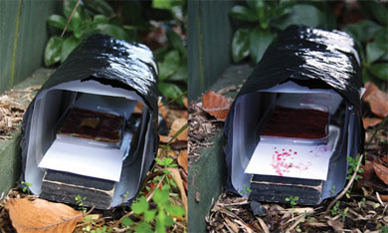
Tracking tunnel

About tracking tunnels
- A tracking tunnel is easy to make and records what is living in your backyard.
- In the bush, DOC rangers use tracking tunnels to record where small animals pass through.
- Pests like tunnels so they scamper in to get the bait and then leave their footprints on the paper as they pass through.
- The footprints show what animals are there and where the animals will feed.

Explore your backyard
Explore your garden work out some different spots to put your tracking tunnel. Think about what might be there and what sort of places they might live, use for food or walk around in. Look for different types of places in your garden that you could use.

Build and use your tracking tunnel
Now you’ve found some spots, build a tracking tunnel. It can be as easy or as fancy as you like. Use your imagination to build something spectacular!
Put your tracking tunnel out in the garden overnight. Maybe even try a few different spots on different nights, or try using different food to see what is popular. Experiment by putting a few tunnels around your backyard. You can disguise your tunnel in the roots of a tree or even cover it with sticks. Be as sneaky as a stoat!
Look at your results and try to work out who is visiting your garden. Is it who you thought you would find?

Collect the items you’ll need
- 2 large plastic milk bottles
- A craft knife or scissors
- A piece of wood
- Polythene wrap
- Red food colouring
- A sponge
- A small plastic tray
- Peanut butter or raw meat
- Sheets of white paper
- A piece of wire

Make your tunnel
- Cut off both ends of the large milk bottles.
- Slide one bottle into the other.
- Slide in a piece of wood for a base.
- Darken the tunnel by wrapping it in polythene.
- Soak a sponge in red food colouring and place it on the plastic tray.
- Put some bait on a leaf and place it in the middle of the sponge. Use peanut butter for rats and mice and raw meat for mustelids like stoats.
- Place the tray in the middle of the tunnel and put sheets of paper at both ends.

Use your tunnel
- Find a good place in your backyard to put your tunnel. To hold your tunnel in place make the piece of wire into a U shape and place it over your tunnel and into the ground.
- Check your papers each morning. You may have to add new bait and food colouring. After 4 - 5 days you should have a good idea of what small animals are around.
- Visit the NZ Kiwi Foundation website (external site) to see what different footprints look like so you can tell what’s in your backyard. Or

Trap your backyard pests
You can catch mice or rats by placing a trap in your tunnel. Placing your trap in the tunnel makes the trap less dangerous for birds and it means the pest animal can’t move sideways to sneak past the trap’s bar.
The Predator Free New Zealand Trust website (external site) has information on trapping pests.

Claim your Kiwi Guardians medal
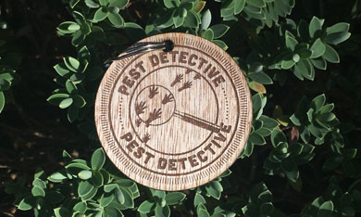
Kiwi Guardians medal for becoming a pest detective
Tell us about what is living in or visiting your backyard and we’ll send you Kiwi Guardians Pest Detective medal.
- What did your tracking tunnel look like?
- What did you find was in your backyard?
- What was the most popular spot, or most popular food to attract the animals and insects you found?
Each Kiwi Guardians action has a different medal - see how many you can collect.
If you share something online use #KiwiGuardians so we can see what you’ve done and share it with others!
Claim your Kiwi Guardians medal
"We built three tracking tunnels and tracked a Hedge Hog within the back yard. We used the NZ Kiwi Foundation website to identify the foot prints. Instead of using polythene we wrapped the milk containers in masking tape, this helped keep the containers together This has been an exciting project for the kids (and their parents). We will continue set the bait etc."
Sophie, Ethan & Jake, Porirua

More information
Pest Detective (external site) - an online tool to help people in New Zealand identify the presence of pest animals.

