Computer Science and the Life Cycle of a Kōkako

“Sorting Networks” is a format for an algorithm originated from the Computer Science Unplugged resource. It is an algorithm which would sit under the Computational Thinking progress outcomes in the Technology Curriculum. Sorting Networks are used to sort values into ascending order by comparing pairs of values. These can be
- Numbers
- Maori numbers
- Chime bar notes from lowest to highest (or vice versa)
- Story sequence
- Life cycles
- etc

Sorting networks topic from CS Unplugged: https://cs-unplugged.appspot.com/en/topics/sorting-networks/

A video of a number Sorting Networks in progress: https://classic.csunplugged.org/sorting-networks/

Here’s the Sorting networks template: https://storage.googleapis.com/cs-unplugged.appspot.com/static/resources/Sorting%20Network%20(blank%20-%20a4).pdf

Lesson plan (adapted from CS Unplugged):
- Organise students into groups of six. Only one team will use the network at a time.
- The current team should stand on the circles at the "input" end of the Sorting Network.
- Give each of the six students a card to hold (initially use a set of cards containing the numbers from 1 to 6 to learn the process then 6 cards showing 6 different aspects of the kōkako life cycle; the cards should be given to the students out of order). These cards are the inputs into this cool chalk or hoop computer (this is a special kind of computer that can process several operations at the same time).
- Get the first two students to follow the lines from their circles until they meet at a box (others watch closely).
- When the two have entered the box, they should say “Hello” to each other (this is to make sure that they stop, and both engage in this step), and then compare cards to decide who has the lower number and who has the higher number of who has the earlier part of the kōkako life cycle
- The student with the lower number or earlier part of the life cycle should follow the line out to the left and go to the next box, while the person with the higher number or higher part of the life cycle follows the line leaving to the right to go to the next square.
- Now get the next pair of students to do the same, meeting at a box and leaving it with the smaller to the left and the larger to the right.
- You can now get the remaining pair of students to do this (remind them to say hello when they meet).
- Once they have the idea, tell them to repeat this process until they get to the end of the network. If someone gets left behind, have the students go back to the beginning; they will need to pay attention when they meet at a square, and ensure that both people who have met know the outcome.
- When they have all reached the circles at the other end of the network have them turn and face the starting circles and read what’s on their card, from left to right. They should be in the correct order from smallest to largest or earliest part of the life cycle to the latest; if not, they may need to try again and work more carefully.
- When each group has been through the Sorting Network, introduce a Sorting Network race to see which group can successfully complete the task in the shortest amount of time (either with two Sorting Networks racing teams at the same time, or one network with the times measured using a stopwatch).

I used these images for the kokako Life cycle. Suggest use LEARNZ acquired images to protect copyright
- Kōkako eggs
- Kōkako baby chicks with adult
- Fledgling kōkako chick
- Two young kōkako
- One adult kōkako
Two adult kōkako representing the fact that they take a mate for life
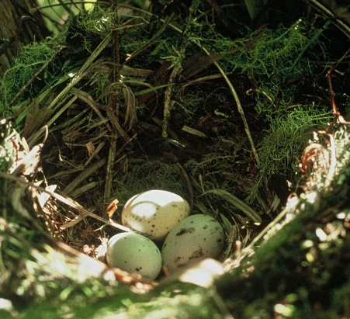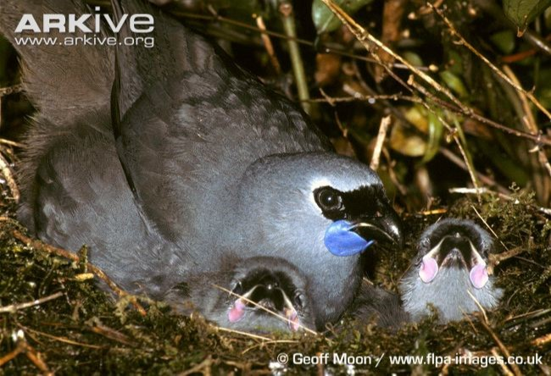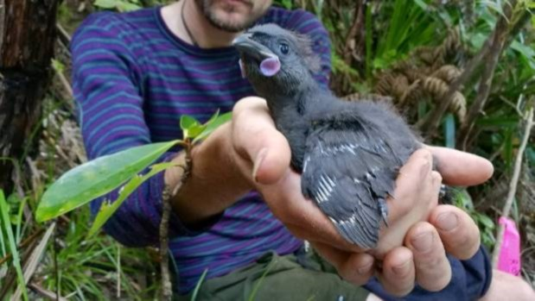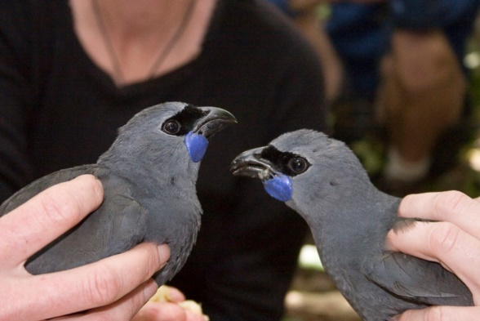
Students from Ilam School completing this activity:
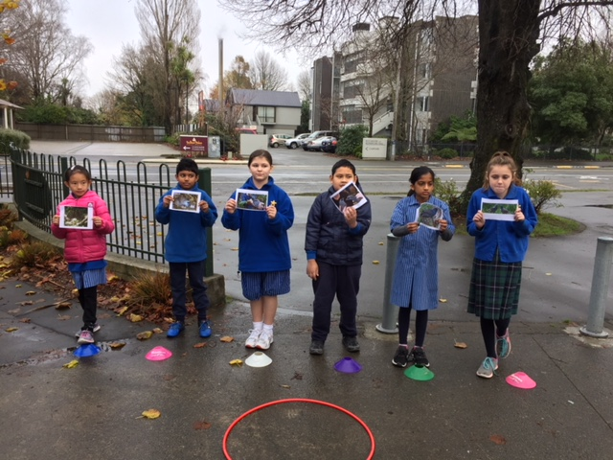

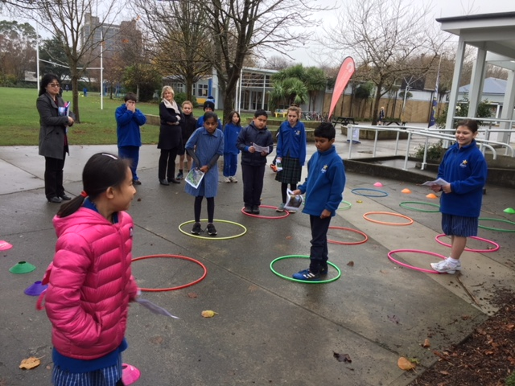

Thanks to Jo Dudley from Ilam School for sharing this activity

