ACTIVITY: Environmental thinking and planning with
ecosystem-based management (EBM)

Activity idea

In this activity, students learn about EBM as a collaboration tool and investigate some of the components of EBM using a local marine or freshwater location as the context. The activity is readily adaptable for use with other environmental planning and/or management projects.

By the end of this activity, students should be able to:
- view and discuss the Sustainable Seas EBM infographic
- discuss some or all of the EBM principles and how this type of information helps with ecosystem management
- use frameworks to consider how some or all of the components relate to the management of a local area of their choice
- develop a simple planning and/or management strategy for a local area or environmental project of their choice.

Background information for teachers
Teacher instructions
Student instructions

Background information for teachers

EBM – ecosystem-based management – is a broad and inclusive approach for managing an ecosystem. It differs from many other management approaches in that it includes humans as part of the ecosystem interactions. Learn more about EBM in the article Looking at EBM.

Developing EBM is at the core of the Sustainable Seas National Science Challenge. The Challenge’s working definition of EBM is: “a holistic and inclusive way to manage our marine environments and the competing uses for, demands on, and ways New Zealanders value them”. This definition may change as it co-develops EBM with Māori and stakeholders.

This activity enables students to develop some of the thinking skills and/or information gathering that goes into developing EBM for a specific area of importance to them. It uses the six principles of the Sustainable Seas Challenge EBM as a framework. Like EBM, this activity is quite broad. Teachers can use all of the components or select those most suited to student ability or interest. The document is in Word, so adapt the student handouts as desired.

Although this activity refers to a local marine or freshwater area, the same thinking can be used when planning for a local project such as developing a community garden or an environmental restoration activity.

Discussing and planning for environmental management provides students opportunities to present differing viewpoints. The resource Managing classroom discussions has suggestions for facilitating discussions to maintain a positive, safe atmosphere.

Teacher instructions

- Briefly discuss EBM as a management system. Use the article Looking at EBM for background information.

- Display the Sustainable Seas EBM infographic/image. Discuss the six principles of EBM – the titles, language and symbols used for each.

- Ask students to choose a local marine area/waterway of interest to them.

- Work through some or all of the EBM principles. Each principle uses Hub resources that will be helpful for background information or to help students refine their thinking about the local area and its value and/or use. Use the student instructions handouts to record ideas. If desired, edit the text to suit your programme.

- For EBM component 3: Human activities, the activity Fisheries role-play lets students take on the role of various stakeholders in New Zealand fisheries. In these roles, students debate the statement ‘there are plenty of fish in the sea’. You can adapt the activity to fit your local situation. For example, ‘there is plenty of clean water in our local river’. Stakeholders might include water bottling industry, whitebait enthusiast, local iwi, kayaker and horticulturist/farmer using irrigation. The articles Human impact on rivers, Human impact on estuaries and Human impacts on marine environments also provide helpful background information.

- Create your own EBM infographic image using the customisable EBM template. This will create a concise representation of student planning and/or management strategies for a local area or environmental project of their choice (optional).

- If students are using this activity to plan for a local environmental project, use the action planner to organise information and begin to make plans for the next step in the project.

Student instructions

EBM component 1: Collective decision-making

This EBM principle is about encouraging engagement and participation from the various groups/stakeholders who have an interest in the ecosystem.

Consider and record your ideas and answers to the following questions. If you don’t know the answer, how or where might you find the information?

- Who owns or manages the area at present?

- Who uses the area?

- Are there groups who use this location for:

- business/industry?

- recreation?

- conservation?

- other purposes?

- Who are the local iwi and what are their thoughts, stories and history of the area?

- Do the local, district and/or regional councils have regulations regarding this area?

- How might you contact the groups/stakeholders identified in the above questions?

EBM component 2: Sustainable

In its most basic form, sustainability is learning to think and act in ways that safeguard the wellbeing of people and the planet (NZC Education for sustainability). People can have very different views about sustainability. This component explores the relationships between people and the environment.

There are four aspects of sustainability to consider: environmental, social, cultural and economic. Aspects of sustainability – teacher resource gives a brief explanation of each aspect and concept as they relate to the context of the Waikato River. Read through the resource to gain a better understanding of each aspect. Then fill in the table with concepts and examples relevant to your chosen area.

Aspect | Concept(s) | Example(s)of actions to support this aspect
Environmental sustainability
Maintaining and enhancing the natural systems that sustain ecosystem life.

Social sustainability
Equity within and between generations and within and between ethnic and social groups. It’s based on the fair distribution of natural resources.

Cultural sustainability
The nourishment and sharing of attitudes and values that represent diverse ways of viewing the world. Citizens have the opportunity to express their views freely and participate in decision-making.

Economic sustainability
Using resources to provide necessary and desirable products and services without compromising the ability of future generations to do the same.

EBM component 3: Human activities

EBM differs from many other environmental management approaches in that it recognises human interactions as part of an ecosystem. Groups/activities may be competing with each other – or with non-human users/activities (such as fish eating kelp or filtering the water in estuaries) – for resources within the ecosystem.

After the Fisheries role-play activity, consider and record your ideas and answers to the following questions. If you don’t know the answer, how or where could you find the information?

- What are the human activities that are part of the ecosystem in your chosen location?

- Business and/or industry

- Māori connections

- Recreational uses

- Conservation activities

- Other

- How might these activities affect the area?

- Are there competing needs for the resources?

EBM component 4: Adapts

Ecosystems are dynamic. They are connected to other parts of the environment and are subject to change. The ways in which we use the land connected to our chosen area may have significant impacts. Other impacts can come from natural occurrences such as floods, drought or climate change.

What changes might happen to this area in the future? What are the causes? What may happen? What would you like to happen?

The Futures thinking toolkit is a framework that will help you develop a scenario for your area. Think about your chosen area and answer the following questions.

Existing situation
What happens in your local area now and why?

Trends
Are there changes to the area? Are they desirable? Are they beneficial to everyone?

Drivers
What is causing the changes and why?

Possible futures
What might happen to your area in the future?

Probable futures
What is most likely to happen to your area in the future?

Wild cards
What unlikely events might occur that would have a big impact on your area?

Preferable futures
What do you want to happen and why?

EBM component 5: Knowledge-based

Management decisions should be based on strong science and mātauranga Māori.

Before you can make decisions about how to manage your area, you need to know what is there. Sometimes, this type of knowledge is held by those who manage the area – such as a regional council or by local iwi as mātauranga Māori. If not, you may need to get some of the baseline data yourselves.

Science knowledge about your area

These articles showcase how students and community groups have gathered information about a local area of importance to them. Read through the articles and make notes about actions they took to gather data. Include any ideas about how you might be able to use similar processes or techniques.

- Project Hotspot
- Sediments and seashores
- Restoring mauri to the Oruarangi Stream

These activities explain how you can gather baseline data about your local area. Make notes about their usefulness and/or how you might use them.

- Making and using a quadrat
- Using a quadrat (video for recording samples of marine life in an estuary)
- Observing freshwater invertebrates

What questions do you have?
Who do you think you could ask?
Where do you think you could find the information?
Notes:

Mātauranga Māori and your area

To be successful, EBM for Aotearoa must be founded on mātauranga Māori as well as science. These articles showcase examples of mātauranga Māori in action. Read through them and make notes about how you might be able to obtain mātauranga from local kuia and kaumātua.

- Reviving toheroa
- Kaitiakitanga and mana whakahaere
- Estuaries – a Māori perspective

What questions do you have?
Who do you think you could ask?
Where do you think you could find the information?
Notes:

EBM component 6: Tailored

Every ecosystem is unique, so it will need to be looked after or managed individually. This component explores the functions and values of various ecosystems. Having this information may help tailor how you want to manage your area.

These articles highlight some of the valuable functions various ecosystems offer to the wider environment and to humans. Read through the relevant information and to help you answer the questions that follow.

Marine
- Valuing estuaries
- Marine habitats
- Habitats in the Bay of Plenty (includes information on rocky and sandy shores)

Freshwater
- Wetlands – the river’s kidneys
- River ecosystems
- River islands
- Peat bogs in the Waikato

These activities highlight some of the unique and valuable functions of various ecosystems.

Marine
- Hubbub Estuary
- Estuary metaphors
- Where do I live?

Freshwater
- River connections

Questions

What is unique about our location?

What part, if any, does it play in a larger ecosystem? Is this important to consider? Why?
What value does it have as an ecosystem?

What value does it have to humans?
How does your community of stakeholders view or value this ecosystem?

What aspects should we include as we draw up our EBM?

EBM for __________________________________ (add your location)

Use the information from your planning sheets to create an EBM infographic.

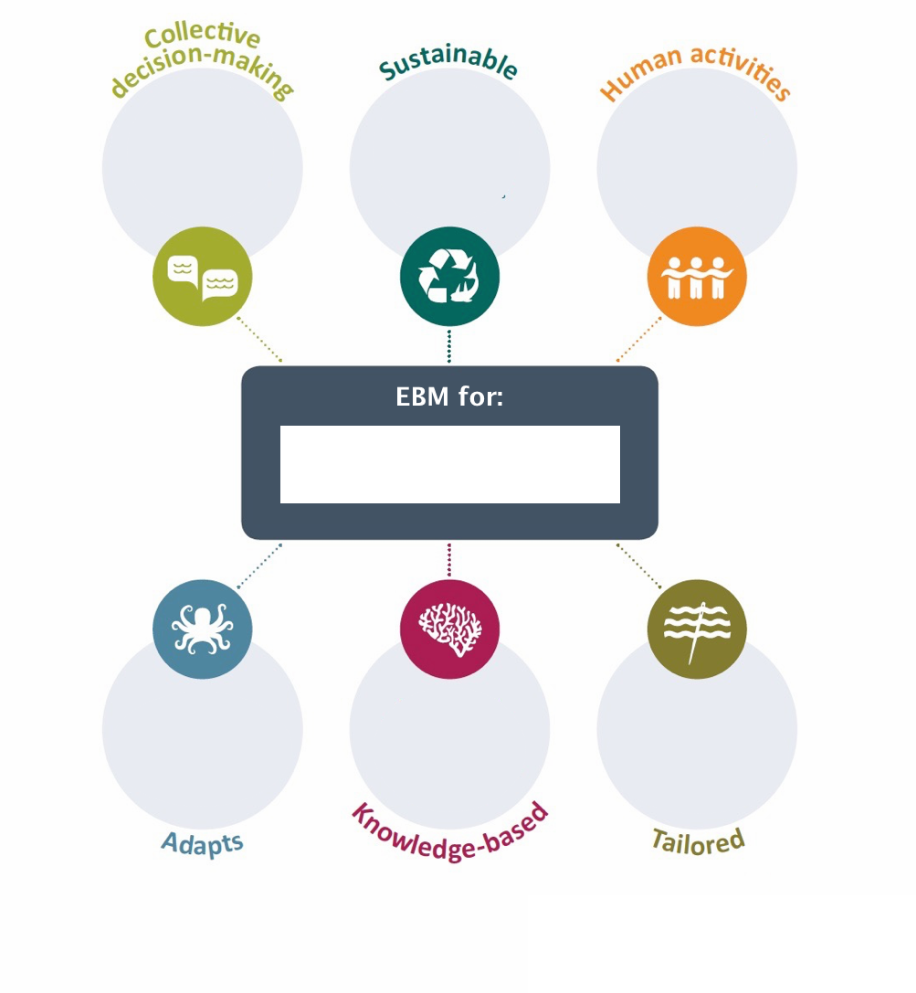

Action planner
How will we monitor the effectiveness of our planning and actions?
How will our actions lead to our vision?
Action Planner

How should we share our plans with the community?
How do we know what others think and value?
What is our timeframe?
What is our vision?
Who do we need to consult before making our decisions?
What information and resources to we need?
Who do we need to involve?
What are we going to do?

