Exploring the Extreme Environment of Antarctica Level 3 & 4
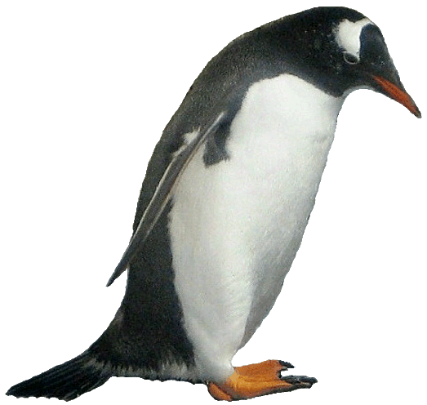 | A History of Exploration and Achievement  Surviving in the extreme conditions of Antarctica is a challenge. Cold and windy conditions are immediately apparent south of the 60˚ latitude line, when the sea and air become very much colder. The first ships that sailed into these waters encountered rough seas, large waves and ice-bergs. When Captain Cook sailed into Antarctic waters in 1773 and found rocks embedded in icebergs, so he guessed there was a land mass further south. Last century, in the early 1990’s, people began to venture into the interior of Antarctica in the interests of exploration, science and the mapping of this new continent. Some of the early expeditions are listed in the table below.  Expedition leader Achievement Challenge  Carsten Borchgrevink Great Britain 1899 Landed at Cape Adare and built huts. First confirmed landing on the Antarctic continent. Spent the first winter in Antarctica. They chose one of the most inhospitable places in Antarctica to build a hut. It was very windy and cold.  Captain Scott United Kingdom 1901 The first Antarctic expedition to try to reach the South Pole. They reached 82˚ south before turning back. Snow blindness, scurvy.  Ernest Shackleton United Kingdom 1907 The expedition came to within 156km of the South Pole Food supplies ran out.  Douglas Mawson Australian 1909 Reached the South Magnetic Pole Food needed to be rationed. Low -24˚C temperature. Man hauling sledges through unknown terrain.  Roald Amundsen Norwegian December 1911 Reached the South Pole for the first time. Amundsen used skis and sled dogs, both of which he was familiar with. Amundsen was the first to travel this route, but he was able to travel quickly and efficiently in the harsh environment.  Captain Robert Scott Britain January 1912 Reached the South Pole 35 days after Amundsen. Cold, exhaustion and lack of food. All of the five man team perished on the return journey, only 18km from a supply depot.  Douglas Mawson Australian 1912 Trekked across George V land back to base in Commonwealth Bay. A new section of coast was discovered. Radio was used for the first time in Antarctica. Mawson’s two companions died; Belgrave Ninnis fell into a crevasse and Xavier Mertz suffered frostbite and died after eating husky dog liver. Mawson was alone for much of his return trek.  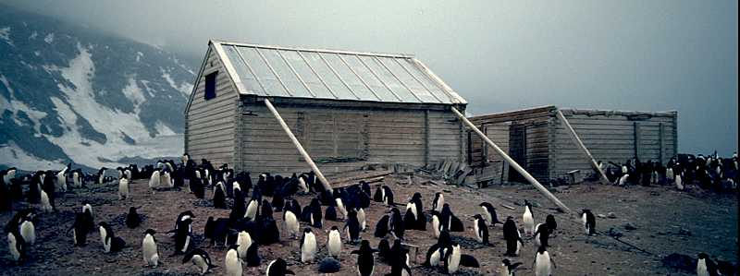  Shelter in the Snow  The early explorers built kitset huts with timber carried on the ships they sailed to Antarctica in. These huts were often cold and uncomfortable to live in. Some huts were insulated with seaweed or paper mache against the cold temperatures and wind. Carsten Borchgrevink’s hut at Cape Adare is pictured Photo; Wikipedia  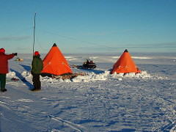  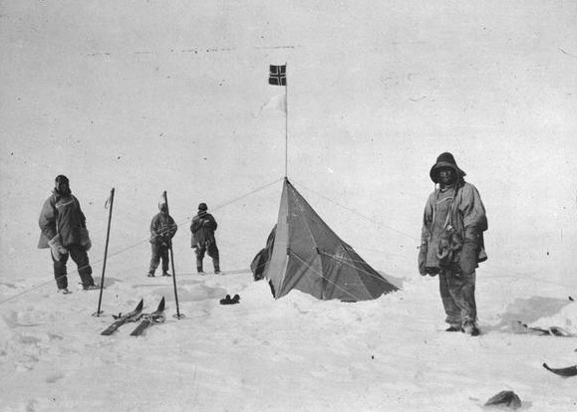  Tents were used to in the early 1900’s to sleep in, and for shelter, when groups went out on sledging expeditions into the interior of the continent. The same design is still used today by scientists and explorers in Antarctica. The triangle shape withstands high winds. Polar tents have a flap around the outside so that snow can be piled onto it to secure the tent.  Photos; Wikipedia  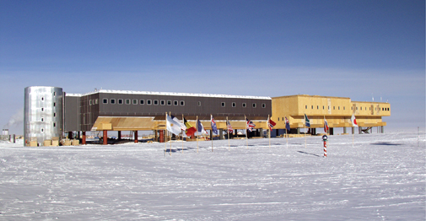  Research Stations  Different countries have built research stations for their scientists to work from. There are a variety of designs that are all constructed with the harsh climate of Antarctica in mind. The Amundsen-Scott Station at the South Pole (right) was built by the United States of America. Some of the stations are supported on piles that allows snow to blow under the building, rather than accumulating against the building. The research bases are all securely fixed into the rock or ice, depending on the surface and where they are built. Some stations are able to be moved in case of changes in the ice they are anchored onto. Most of the permanent bases have people living in them all year around, with lower numbers of people during winter. Summer is a busy time for scientists as the sunlight hours are long and the weather is a little warmer. The research stations are well-heated and insulated compared to the timber huts of the heroic era explorers.  Clothing  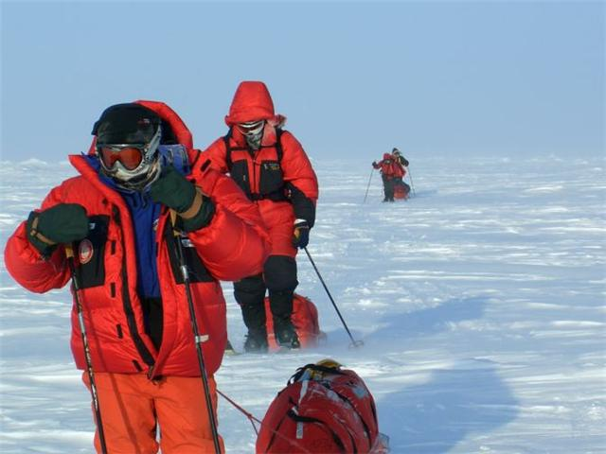  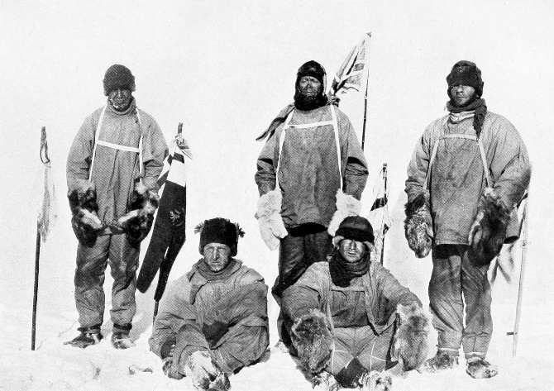  Early Antarctic explorers wore heavy layers of woolen fabric that absorbed the moisture produced by sweat or condensation. At night this moisture froze, which meant that in the morning clothes that had to be put on were stiff and cold with ice. Scientists and explorers today are able to wear lighter and more efficient fabrics. These materials are lighter and easier to wear. They keep out the cold and wind and keep the wearer warm and dry.  Extreme Cold  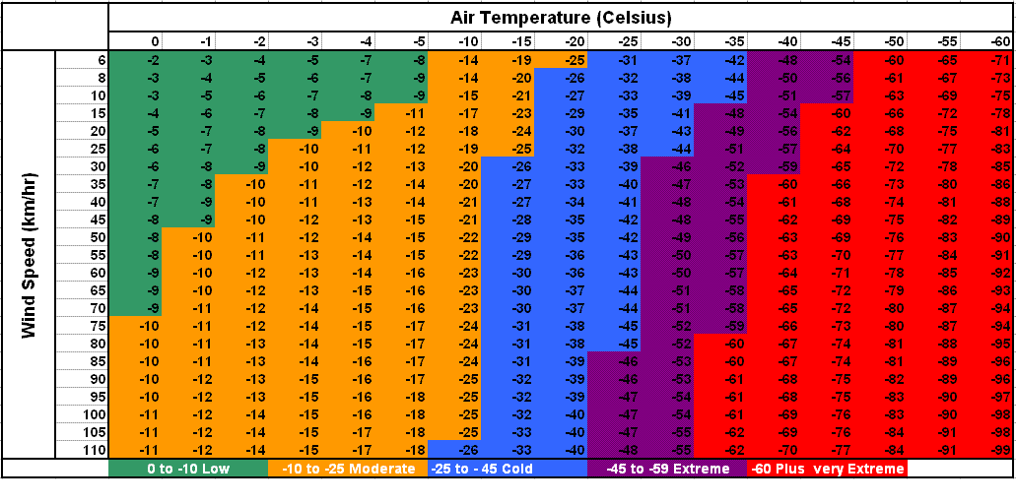  The extreme cold of Antarctica means that people need to be alert to the dangers of the environment. Early explorers suffered from frostbite and hypothermia in the cold conditions. When a wind is blowing, a wind chill factor is added to the day’s temperature, lowering the actual temperature. Frostbite is when parts of the body; usually the fingers, toes and face, become so cold the tissue starts to freeze. Hypothermia is a general chilling of the body, leading to a fall in the internal body temperature. The chart below shows the effect of wind on an already cold environment which will in turn affect anything living.  Snow blindness was common among explorers. Today sunglasses and ski goggles are worn to prevent this. Dehydration is also a danger as Antarctica is a dry climate and the available water is often in snow or ice form. Drinking 4 litres of water a day is advised to stay healthy.
Questions/ think pair share / discuss
- What do animals, plants or bacteria need to live?
- How do people survive in Antarctica? In what way is this different from animals who live in extreme environments?
- What is hypothermia?
- What is the wind chill factor? What could you do to prevent hypothermia or frostbite?
- The research stations are mainly around the edge of the Antarctic continent. Why do you think this is? What does this mean for the scientists?
Activities
- This website has an online wind chill calculator. Use it to calculate some wind chill factors. http://www.srh.noaa.gov/epz/?n=wxcalc_windchill
- Design your Antarctic research station. Remember you are building in the coldest, windiest and driest place in the world. The early explorers sometimes suffered from scurvy; a lack of Vitamin C found in fruit and vegetables. How could you counter this possibility?
- Make a list of your Antarctic clothing. These websites might help.
http://www.rte.ie/tv/tomcrean/assets/kids-corner-clothing.pdf
http://www.coolantarctica.com/Antarctica%20fact%20file/science/clothing_in_antarctica.php
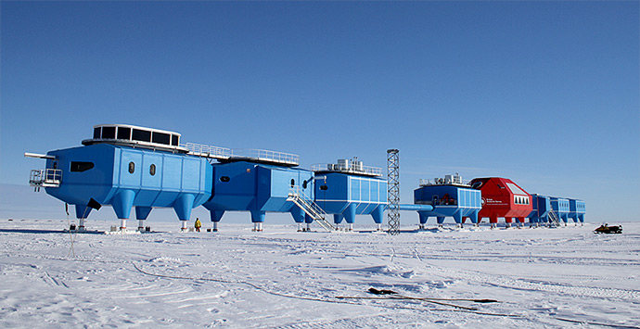
http://discoveringantarctica.org.uk/science-and-exploration/living-in-antarctica-today/what-not-to-wear/
- Why is the station “on legs”?

Photo; Paul Knight
The British Halley VI research station; described as “dismantable.” Why is this a good description, and a good idea?
Practical Work
The surface of your skin will naturally lose the heat of your body. If a wind is blowing over your skin the heat loss is increased.
Try this:
- Hold your hand in front of a moving current of air; a fan, or outside if it is windy (and cool). The faster the wind, the more rapidly your skin will cool as the warm layer of air is moved away from your body.
- Wet your hand and then place in front of the moving air.
- Use an ice cube to cool the skin on the back of your hand, then hold your hand in front of the moving air. Does it feel warmer or cooler?

