Rock Daisy Action
At about 2 minutes 9 seconds in the second video for Wednesday with Clark Butcher, titled The Reconstruction of State Highway 1, we filmed some abseilers up on Ōhau Bluff – and inadvertently captured a piece of New Zealand’s conservation history!
As it turns out, those abseilers were replanting the rare Ōhau Rock Daisy on behalf of the Department of Conservation (DOC). The daisy only grows at Ōhau Point. Its habitat was almost wiped out by that monster landslide. NCTIR has been provided the ropes-on-the-slopes skills to retrieve seeds (last year) so that DOC can try and re-establish the plant population.
Below is a media release with images about efforts to restore the Ōhau rock daisy population at Ōhau Point on the Kaikōura coast that was damaged in the November 2016 earthquake.

Media release
5 July 2018
More rock daisies growing at Ōhau Point
The outlook is looking brighter for the native Ōhau rock daisy enduring on its earthquake-damaged Kaikōura coastal home with new plantings and new growth emerging.
The Ōhau rock daisy only grows on the Ōhau Point coastal bluffs and its habitat was hit by a landslide in the November 2016 Kaikōura earthquake. Department of Conservation staff estimated only 80-100 plants remained and an estimated 95% of its habitat had been wiped out when they checked the plants by helicopter after the earthquake.
Seed from six surviving plants on the steep slope was collected by abseilers from the North Canterbury Transport Infrastructure Recovery (NCTIR), the delivery arm of the New Zealand Transport Agency and KiwiRail’s rebuild of State Highway 1 and the Main North Line. The seeds were taken to Titoki Nursery near Nelson where rock daisy seedlings were grown from the seeds to restore the population.
Last month DOC staff planted 50 of the propagated rock daisy plants back on their Ōhau Point bluff home and NCTIR abseilers are planting another 12.
DOC South Marlborough Senior Biodiversity Ranger Jan Clayton-Greene said NCTIR staff had also reported seeing rock daisy plants on the bluff resprouting from stumps of damaged plants.
“The new plantings and regrowth give us hope of rebuilding the Ōhau rock daisy population but it is early days yet for knowing whether these rock daisies will survive. We will monitor them to determine how well they fare.
“The Ōhau rock daisy population was perilously at risk of extinction due to the sudden drop to such low numbers and in a location where further landslides might occur.
“We now want to get as many rock daisies growing there as we can as the more plants there are, the more seeds will be dispersed into the landscape to help the population recover quicker.”
“The Kaikoura abseiling teams were pleased to be involved in retrieving the daisy seeds and we hope to use the plants grown from them in new places around Ōhau Point,” says Tim Crow, Transport Agency Earthquake Recovery Manager.
“It is great to not only retain this pre-earthquake uniqueness but give the daisy the best opportunity to thrive in its changed home.”
NCTIR plans to put 67 of the propagated rock daisy plants in amenity plantings by the rebuilt transport route at Ōhau Point and some seeds from these are also expected to blow onto the bluffs to create new growth.
Another 36 of the propagated plants will remain at the nursery as an insurance population so Ōhau rock daisy plants continue to exist should there be a threat to the survival of those in their natural environment.
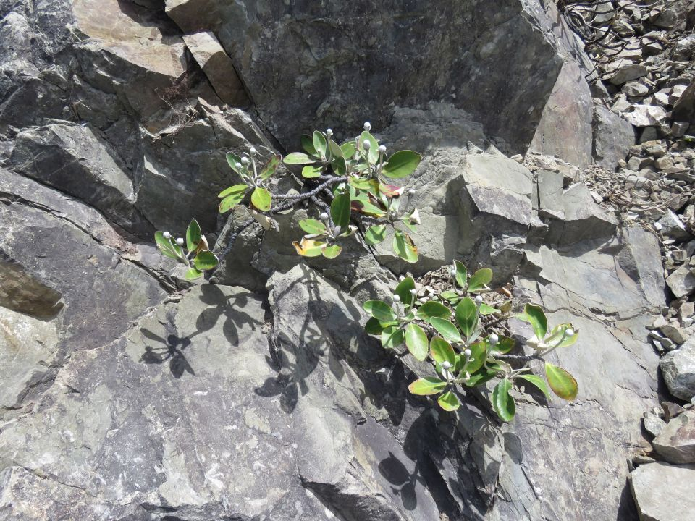
Ōhau rock daisy. Photo: DOC.
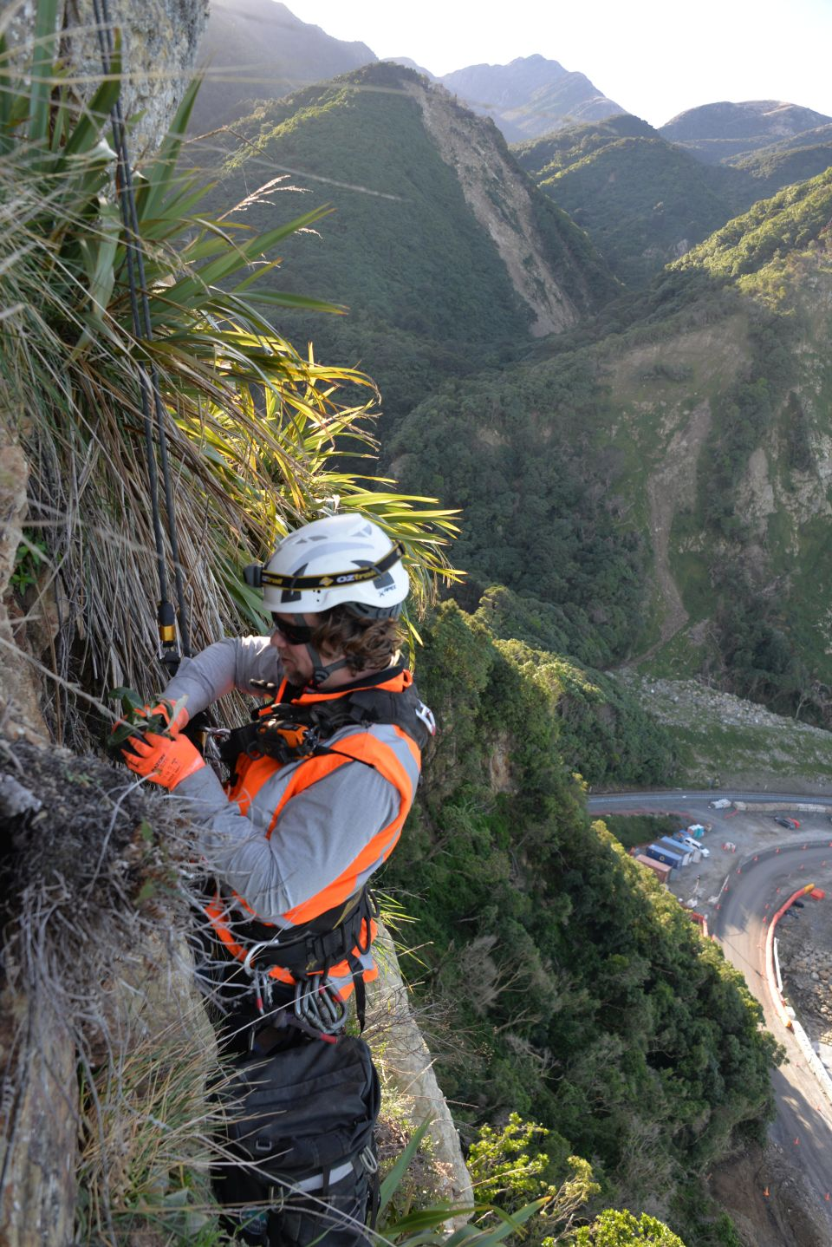
NCTIR Environmental Advisor Ryan Sutherland abseils to plant an Ōhau rock daisy on the Ōhau Point bluff. Photo: NCTIR.
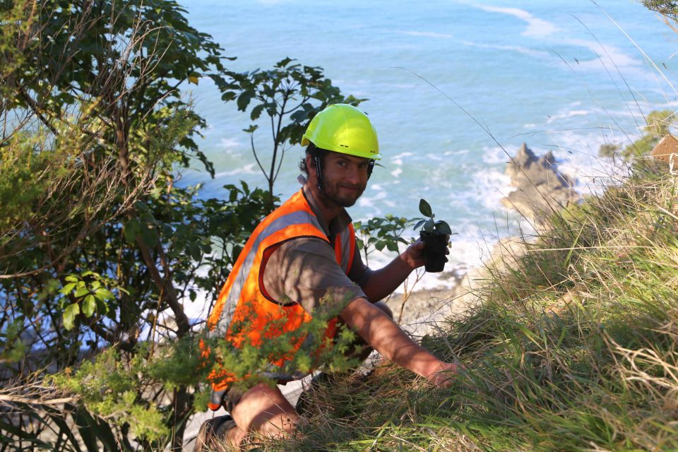DOC ranger Simon Litchwark planting an Ōhau rock daisy on the Ōhau Point bluff overlooking the Kaikōura coast. Photo: NCTIR.

