Creating a Memorial Park
Read the Background Pages before attempting the activity | Curriculum Area:  Social Studies, Technology Levels 2-5 | Strand  Place and Environment, Culture and Organisation, Continuity and Change  Nature of Technology
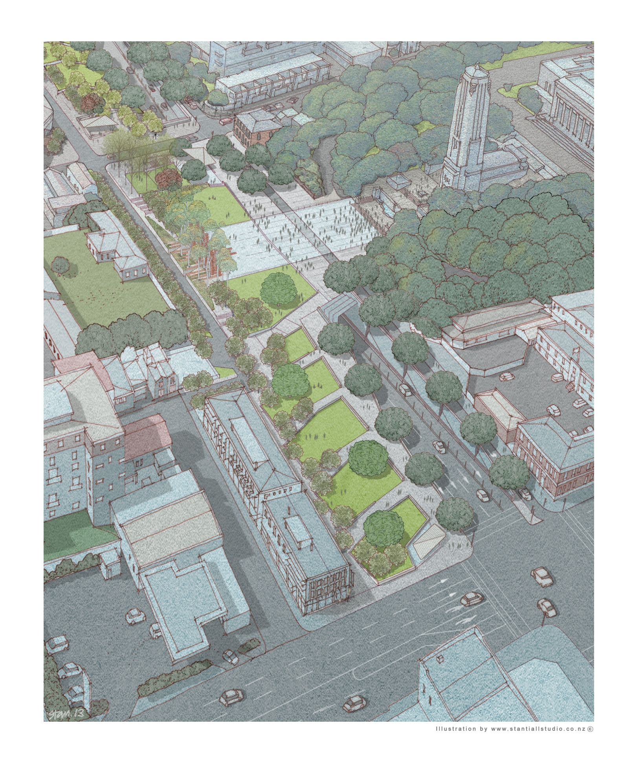  Achievement Objectives | Understand how people view and use places differently.  Understand how people participate individually and collectively in response to community challenges.  Understand that events have causes and effects.  Understand how technological development expands human possibilities and how technology draws on knowledge from a wide range of disciplines
- Who is working on the Memorial Park project and why is more than one organisation involved?
____________________________________________________________________________________________________________________________________________________________________________________________________________________________________________________________________________________
- What do you think about the design of Memorial Park and why do you think this?___
____________________________________________________________________________________________________________________________________________________________________________________________________________________________________________________________________________________
- Design your own Memorial Park for your local community. Draw and draft your ideas below and then choose how you will share your ideas with your class e.g. Make a model, make a poster, role play an advertisement, share on a class wiki/blog, use an app to explain your ideas….

