Geohazards Web Quest

Learning Intentions
- Become familiar with LEARNZ website functions
- Read (skim and scan), watch, listen, and look for information on the Geohazards website
- Use the Geohazards website to create good open-ended (‘fat’) questions
Welcome
Welcome to the Geohazards virtual field trip. During your learning about geological hazards, you will meet real people, doing real jobs, in real places and in real time. So, grab your outdoor clothes and boots, and come exploring with me on the Geohazards website.
Best
Did you know...?
If you have an internet connection at home you can access field trips.
Why not show someone at home what you are learning about?
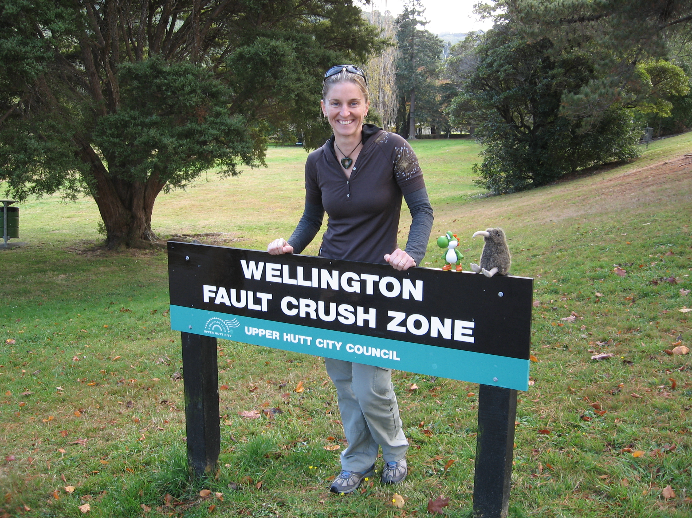
Shelley
Before you Begin...
- Get your LEARNZ class username and password from your teacher
- Go to www.learnz.org.nz
- Click on ‘All Field Trips’ or ‘Field Trip Chooser’
- Click on Geohazards 2014
- Type in your username and password – You are now on the Geohazards field trip site.
Turn over to begin your quest...
Web Quest Section 1 – Preparation
(Click on ‘Preparation’ in the left hand menu bar)
Background Pages: Text roll-overs – These are words in Background Pages that are in a different colour (usually orange) to the rest of the text. When you use the mouse to ‘hover’ over these orange words you will see the meaning of that word appear in a small box.
Find one text roll-over word that interests you from a Background Page. Write the word and its definition here.
QUEST TASK
- Word ___________________ Definition _________________________________________________

Background Pages: Picture slide-show When you click on the first picture in a Background page, you will see that it enlarges. Below the pictures there are three links; Previous, More and Next:
Takes you back to the page
Takes you to the next photo
Takes you to the photo before
Previous | More .. | Next
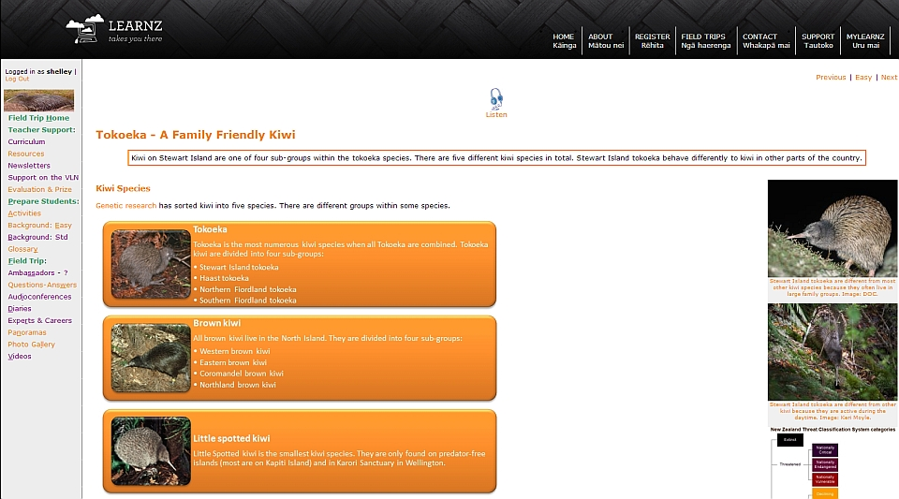
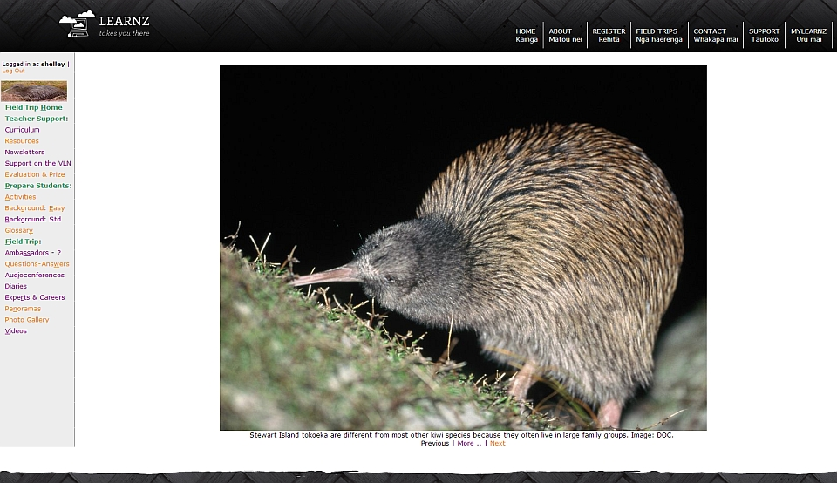

Now turn over to explore some field trip photos …
Open a Background page of your choice and click on the first photo. Click Next to view all the other photos. Now use both Previous and Next to select your favourite photo for that Background page. Complete the following:
QUEST TASK
My chosen photo is from the Background Page called _______________________

This photo shows ____________________________________________________________________

Glossary – Like text roll-overs, the Glossary helps you find definitions of new words from the Background Pages. Click on ‘Glossary’ and write the meaning of a word that is new to you.
- Word ___________________ Definition _________________________________________________

Web Quest Section 2 – Field Trip
(Click on ‘Field Trip’ in the left hand menu bar)
Ambassadors Each class ambassador has their own web page.
Go to the Ambassador page and meet the ambassadors. What are their names? ______________________________________________________________________
QUEST TASK
Imagine that you have your own Class Ambassador on this field trip and are sending him/her a short message. Write a draft for this message:
_______________________________________________________________________
_______________________________________________________________________
_______________________________________________________________________
Ask-an-Expert - This is the place where you can ask questions that have not been answered from your involvement in the Geohazards field trip web site. Questions could come from background pages, activities, audioconferences, class discussions etc.
Click on the Ask-an-Expert link; enter your username and password; in the board index, click on Geohazards: Ask-an-Expert; Click on Guidelines for using Ask-an-Expert and read these; then click on new topic and post a question for an expert to answer.
QUEST TASK
- My Question is ______________________________________________________________________
_____________________________________________________________________________________
NB: Remember to check back the next day to see if your question has been answered.

Audioconferences These are where students talk with experts during the field trip. They are great fun, so if you haven’t been a speaking school before, talk to your teacher about getting involved either on this field trip or the next.
Have a look at the audioconference timetable and the six topics. Select a topic and look at the questions asked by the speaking schools. Select one question that interests you. What is that question?
QUEST TASK
_______________________________________________________________________
_______________________________________________________________________
Listen to the audioconference recording and find the place on the recording where the answer to that question was given. In your own words write the answer to that question:
_______________________________________________________________________
_______________________________________________________________________
_______________________________________________________________________
_______________________________________________________________________
Diaries A detailed diary is written for you to read for each day of the field trip (including the travel day on Monday). There are photos taken that day on this page as well.
QUEST TASK
Select one of the diaries for your field trip.
What is the date?  ________________________________ | What is the location of the field trip?  ________________________________
Where’s the field trip teacher today?  ________________________________ | What is the weather like?  ________________________________
Write one fact you learned from reading the diary.
- My fact is:
_______________________________________________________________________
_______________________________________________________________________
_______________________________________________________________________
- Was there a photo relating to this fact? (Circle one) Yes/No
Panoramas These large format photos help you to see what the surrounding environment is like.
Select and enlarge one of the panorama images in your field trip. Answer the question in the caption. Come up with your own question relating to the panorama photo.
QUEST TASK
- My Question is: ____________________________________________________________________
______________________________________________________________________
Experts/Careers This is where you get to meet and learn about your field trip experts.
QUEST TASK
Read about the experts and complete the following:
- Write the name of the expert you would most like to meet in person:
______________________________________________________________________
- Write an interesting question you would ask that expert:
______________________________________________________________________
______________________________________________________________________
Photo Gallery You can find all the photos from the Geohazards field trip here.
Keyword Search. Have a go at typing in a key word (one related to the Geohazards field trip). Keep trying until you get a result.
QUEST TASK
- My key word is ___________________
- The number of photos found were _________
- The photo I liked the most was about
________________________________________________________________________________________________________________________________________________

Videos About five videos are made each day of the field trip and help you to get amongst the action.
Select and view one video from each day of the field trip and complete the following:
QUEST TASK

Write the day and video number: | Write one fact you learned from watching this video: | Write your own question about this video topic:

- Choose one of these videos and have a go at the ‘next step learning’.
The next step learning question/statement is:
______________________________________________________________________
______________________________________________________________________
My ideas are:
______________________________________________________________________
______________________________________________________________________
______________________________________________________________________
LEARNZ Homepage Map – You can zoom in on the map to get a better idea of where you are on the field trip.
Go to the map on the field trip page of the LEARNZ website and complete the
following:
QUEST TASK

- Zoom in on the LEARNZ flag showing where the Geohazards field trip is taking place:
- Which state highway number is nearest to the field trip location (see the number in the red shield)? SH_____
- What is the nearest town to the field trip location? ______________________________
- Have a look at the Satellite, Hybrid, and Terrain map viewing options.
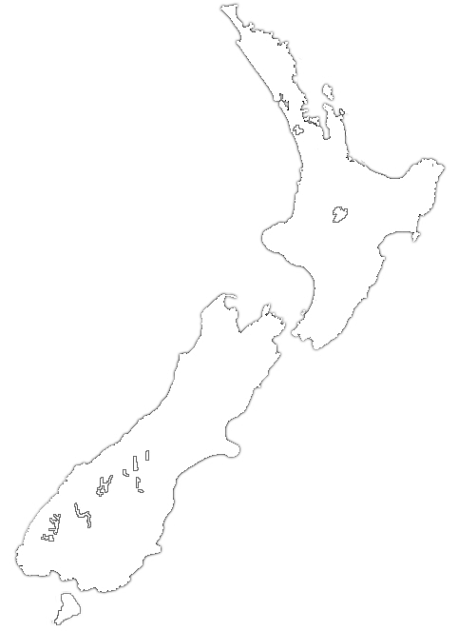
- Put a cross on this map to show where your field trip is located.
- Draw a small house on this map to show where you live.
- Draw a line from your house to the field trip location.

✶                       
Self Assessment
Learning Intention | ☹ | 😐 | ☺
I know more about the Geohazards website functions
I can read, watch, listen, and look for information on the Geohazards website
I can use the Geohazards website to create good, open-ended (‘fat’) questions

