The Geological History of Antarctica Level 5

Main teaching ideas;
- There is evidence supporting the theory of Gondwanaland
- Understanding the mechanisms that drive plate tectonics
- Identification of the different boundaries formed by plate tectonics
- Antarctica’s geological history as part of Pangaea and Gondwanaland.

Key words; Pangaea, Gondwanaland, continent, fossil, tectonic plates, magma, 4 types of plate boundaries; divergent, convergent, subduction, transform (slide)
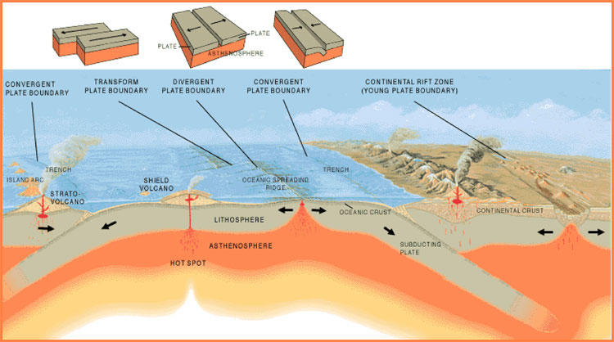
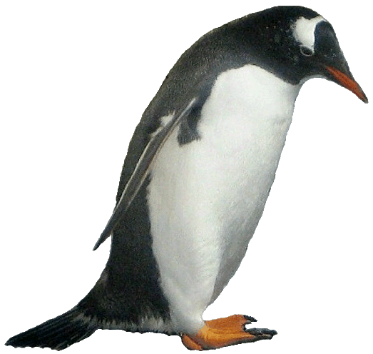 | From Continental Drift to Plate Tectonics  In the 1920’s a scientist, Alfred Wegener, concluded from the jigsaw appearance of the Earth’s coast lines that the continents had once been joined together and had moved slowly apart over time. Wegener’s theory of Continental Drift was initially not accepted as his fellow scientists thought there was not enough evidence for his ideas. Fossil evidence and an understanding of how the continents moved led to an acceptance of his ideas in the 1960’s. His theory led to the modern science of plate tectonics. Convection currents in the mantle of the Earth cause heated rocks to rise and fall again as they cool. These convection currents are moving the continents of the Earth at a rate of about 5cm a year. Where the plates meet are called plate boundaries. Volcanoes, earthquakes, mountain ranges and ocean trenches found along the edge of these boundaries.  The different boundaries are;  - Convergent, where the plates move together.  - Subduction, when converging plates are moving together and one plate slides under the other.  - Divergent, where the plates move apart.  - Transform, where the two plates slide past each other.  http://oceanexplorer.noaa.gov
From Pangaea to Gondwanaland to Antarctica
250 million years ago Antarctica was part of a super continent that we now call Pangaea.
The super continent called Pangaea moved apart and split into two large land masses; Laurasia and Gondwanaland.
Laurasia drifted north and divided into Europe, Asia and North America. Gondwanaland became Antarctica, Africa, South America, India, Australia and New Zealand.
Although most of these latter land masses stayed in the southern hemisphere, one of them did not. India moved north, eventually colliding with the east Asian land mass and forming the Himalayas.
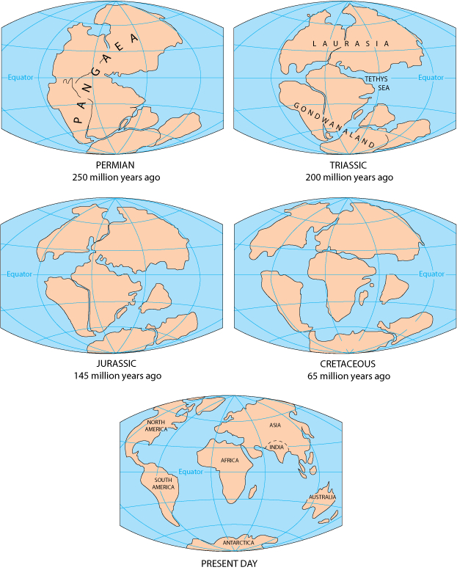

Fossil Evidence
Fossil evidence links all the land masses that once formed Gondwanaland together. Captain Robert Falcon Scott found fossils of the Glossopteris indica, an extinct type of beech tree on his way to the South Pole. Although he would not have known the full importance of the fossils when they discovered them in Antarctica, the heavy rock fossils were found with Scott and his party in their tent. Scott and four of his expedition team were beaten to the South Pole by Roald Amundsen in 1912 and tragically perished on their return journey. The discovery of the tree fossil indicates that the climate would have been warmer in Antarctica at the time this plant grew there, 250 million years ago.
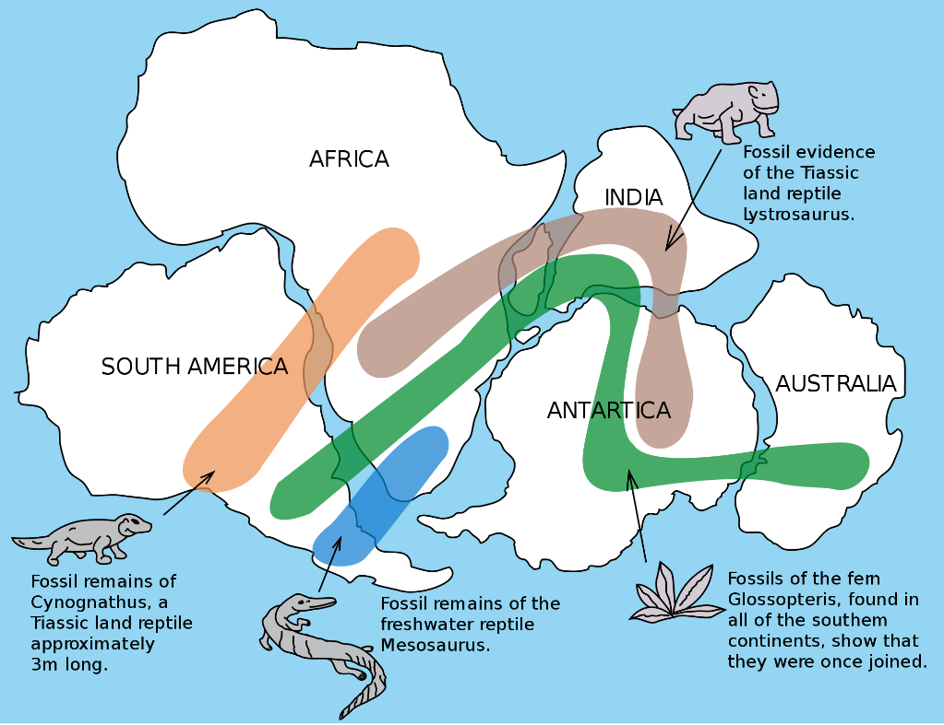

Questions / think pair share / discuss
- What do you think the edges of the different plate boundaries will look like?
- Where is the Rift Valley ? Why do you think it is called that ?
- Discuss the fossil evidence for Gondwanaland. Is it convincing?
- What do you think this fossil evidence can tell us about the climate at the time of Gondwanaland ?

Activities
- Watch the clip; http://www.pbslearningmedia.org/resource/ess05.sci.ess.earthsys.plateintro/plate-tectonics-an-introduction/

- Check out this link for further information about Plate Tectonics

www.geography.learnontheinternet.co.uk/topics/structureofearth.html#struct

- From the link above make up and complete a table summarizing the four different types of plate boundaries.

Plate boundary | Diagram | Description | Landform | Example

- Complete the cloze exercise below.

Pangaea was a super continent that split into ____________________ and _________________ about 250 million years ago. The northern super continent of Laurasia later split into Europe, Asia and North America while the southern super continent of Gondwanaland would eventually split into Africa, India, Madagascar, South America, Australia and Antarctica. This process was driven by _____________pushing upwards and creating pressure on the Earth’s crust. Australia and Antarctica stayed together until about ____________________years ago, when Antarctica started to freeze and Australia drifted northward. The Australian continent is still moving north at a rate of 3cm a year. While ___________________was part of Gondwanaland the planet was warmer than it is today. There was no Antarctic ice-sheet and _________________ roamed the Earth. This was the _______________period and much of Gondwanaland was covered with lush _______________. _________________found by scientists over the years have provided evidence that these land masses were once joined together. From a Viennese geologist, Eduard Suess in the mid-1800s to Captain Robert Scott in 1912, to scientists later in the 20th century, all who collected fossils without understanding the process of______________________________, there was a growing awareness of the significance of these fossils. The name Gondwanaland comes from an area in ____________________ where geological formations match those found in the _____________________ hemisphere.

45 million magma Jurassic Fossils

southern plate tectonics Gondwanaland India

Antarctica rainforest dinosaurs Laurasia

Practical Work

- Using a Mars bar, one per student if possible, explore how a Mars bar can demonstrate plate boundaries.
- Carefully break the hard chocolate surface (the Earth’s crust) by bending the bar.
- When the caramel layer (the mantle) is exposed, pull gently to show divergent plates.
- Continue, demonstrating convergent, subducting and transforming tectonic plates.
- You may now eat the experiment

- Pour a thick liquid; honey, golden syrup or corn syrup into a large beaker.
Place pieces of a broken biscuit on top of the liquid and gently heat, demonstrating the movement of the continents.

