Arrivals and Departures  ANSWERS |  | Curriculum Area:  Mathematics and Statistics, Level 3/4 | Strand:  Statistics
Achievement Objective: | Statistical investigation  gathering, sorting, and displaying multivariate category and whole-number data and simple time-series data to answer questions
Below is a picture of the arrivals and departures screen from Christchurch Airport. Study the picture and answer the questions.
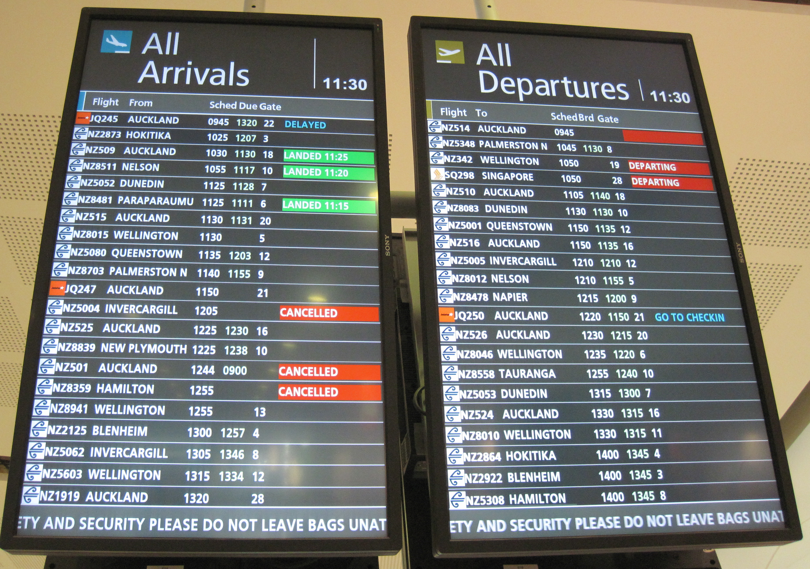
- What time was the photo taken? (11:30 am)
- If you couldn’t read English, what visual cue is there for the difference between arriving and departing? (icons of planes landing or taking off in top left corner - and in different colors)
- How many flight items are shown on the Arrivals board? (21)
- How many flight items are shown on the Departures board? (21)
- How much time is covered in this photo of the Arrivals Board? (3 hours 35 minutes)
- How much time is covered in this photo of the Departures Board? (4 hours 15 minutes)
- How many flights arrive from Auckland? (7)
- How many flights depart for Auckland? (6)
- How many international flights are departing during this time? (1)
- Name the places that have more than one flight arriving? (Auckland, Invercargill, Wellington)
- Name the places that have more than one flight departing? Auckland, Wellington, Dunedin)
- How many different airlines have flights arriving? (2)
- How many different airlines have flights departing? (3)
- If you missed the first Auckland flight, how long after it is the next one? (1hr 20mins)
- If you were to meet someone on the first flight in from Wellington and they were actually on the next one, what is the time difference? (1hr 25mins)
- List all the different messages shown in the right column of the two boards (Landed, delayed, cancelled, departing, go to checkin). What other messages might be shown? (Boarding, go to gate)
- How many flights arrived on time? (none)
- What is the most common amount of time between Shed (scheduled departure) and Brd (boarding time)? (15 minutes)
- Extra questions for discussion:
  - Why are words shown in all-caps when that could be harder to read than mixed-case? (Maybe all-caps better for info in a table that is not sentences)
  - How is colour used on the boards? (icons, messages, inverse for urgent messages like Landed)
  - Look at the flight codes. What patterns can you see? (answers will vary)
  - Why are times shown in military format? (Maybe fewer mistakes as don’t have to put am or pm. Takes up less space and is always 4 digits, world-wide consistency amongst airport systems)
  - Look at the gate numbers. What patterns can you see and speculate why that might be? (Maybe fights to and from big cities have high gate numbers in the 20s because they have air bridges and parking for bigger planes).
  - If you had the job of redesigning the boards, what changes would you suggest, if any. (answers will vary)
  - Why might mathematicians analyse some of the data shown over a days/weeks/months/years? (how many flights on time, if late, how late on average? Is there are difference between punctuality of arrivals and departures?)
  - What suggestions do you have for using technology to improve the user’s experience regarding arrivals and departures? (answers will vary)

