Arrivals and Departures |  | Curriculum Area:  Mathematics and Statistics, Level 3/4 | Strand:  Statistics
Achievement Objective: | Statistical investigation  gathering, sorting, and displaying multivariate category and whole-number data and simple time-series data to answer questions
Below is a picture of the arrivals and departures screen from Christchurch Airport. Study the picture and answer the questions.
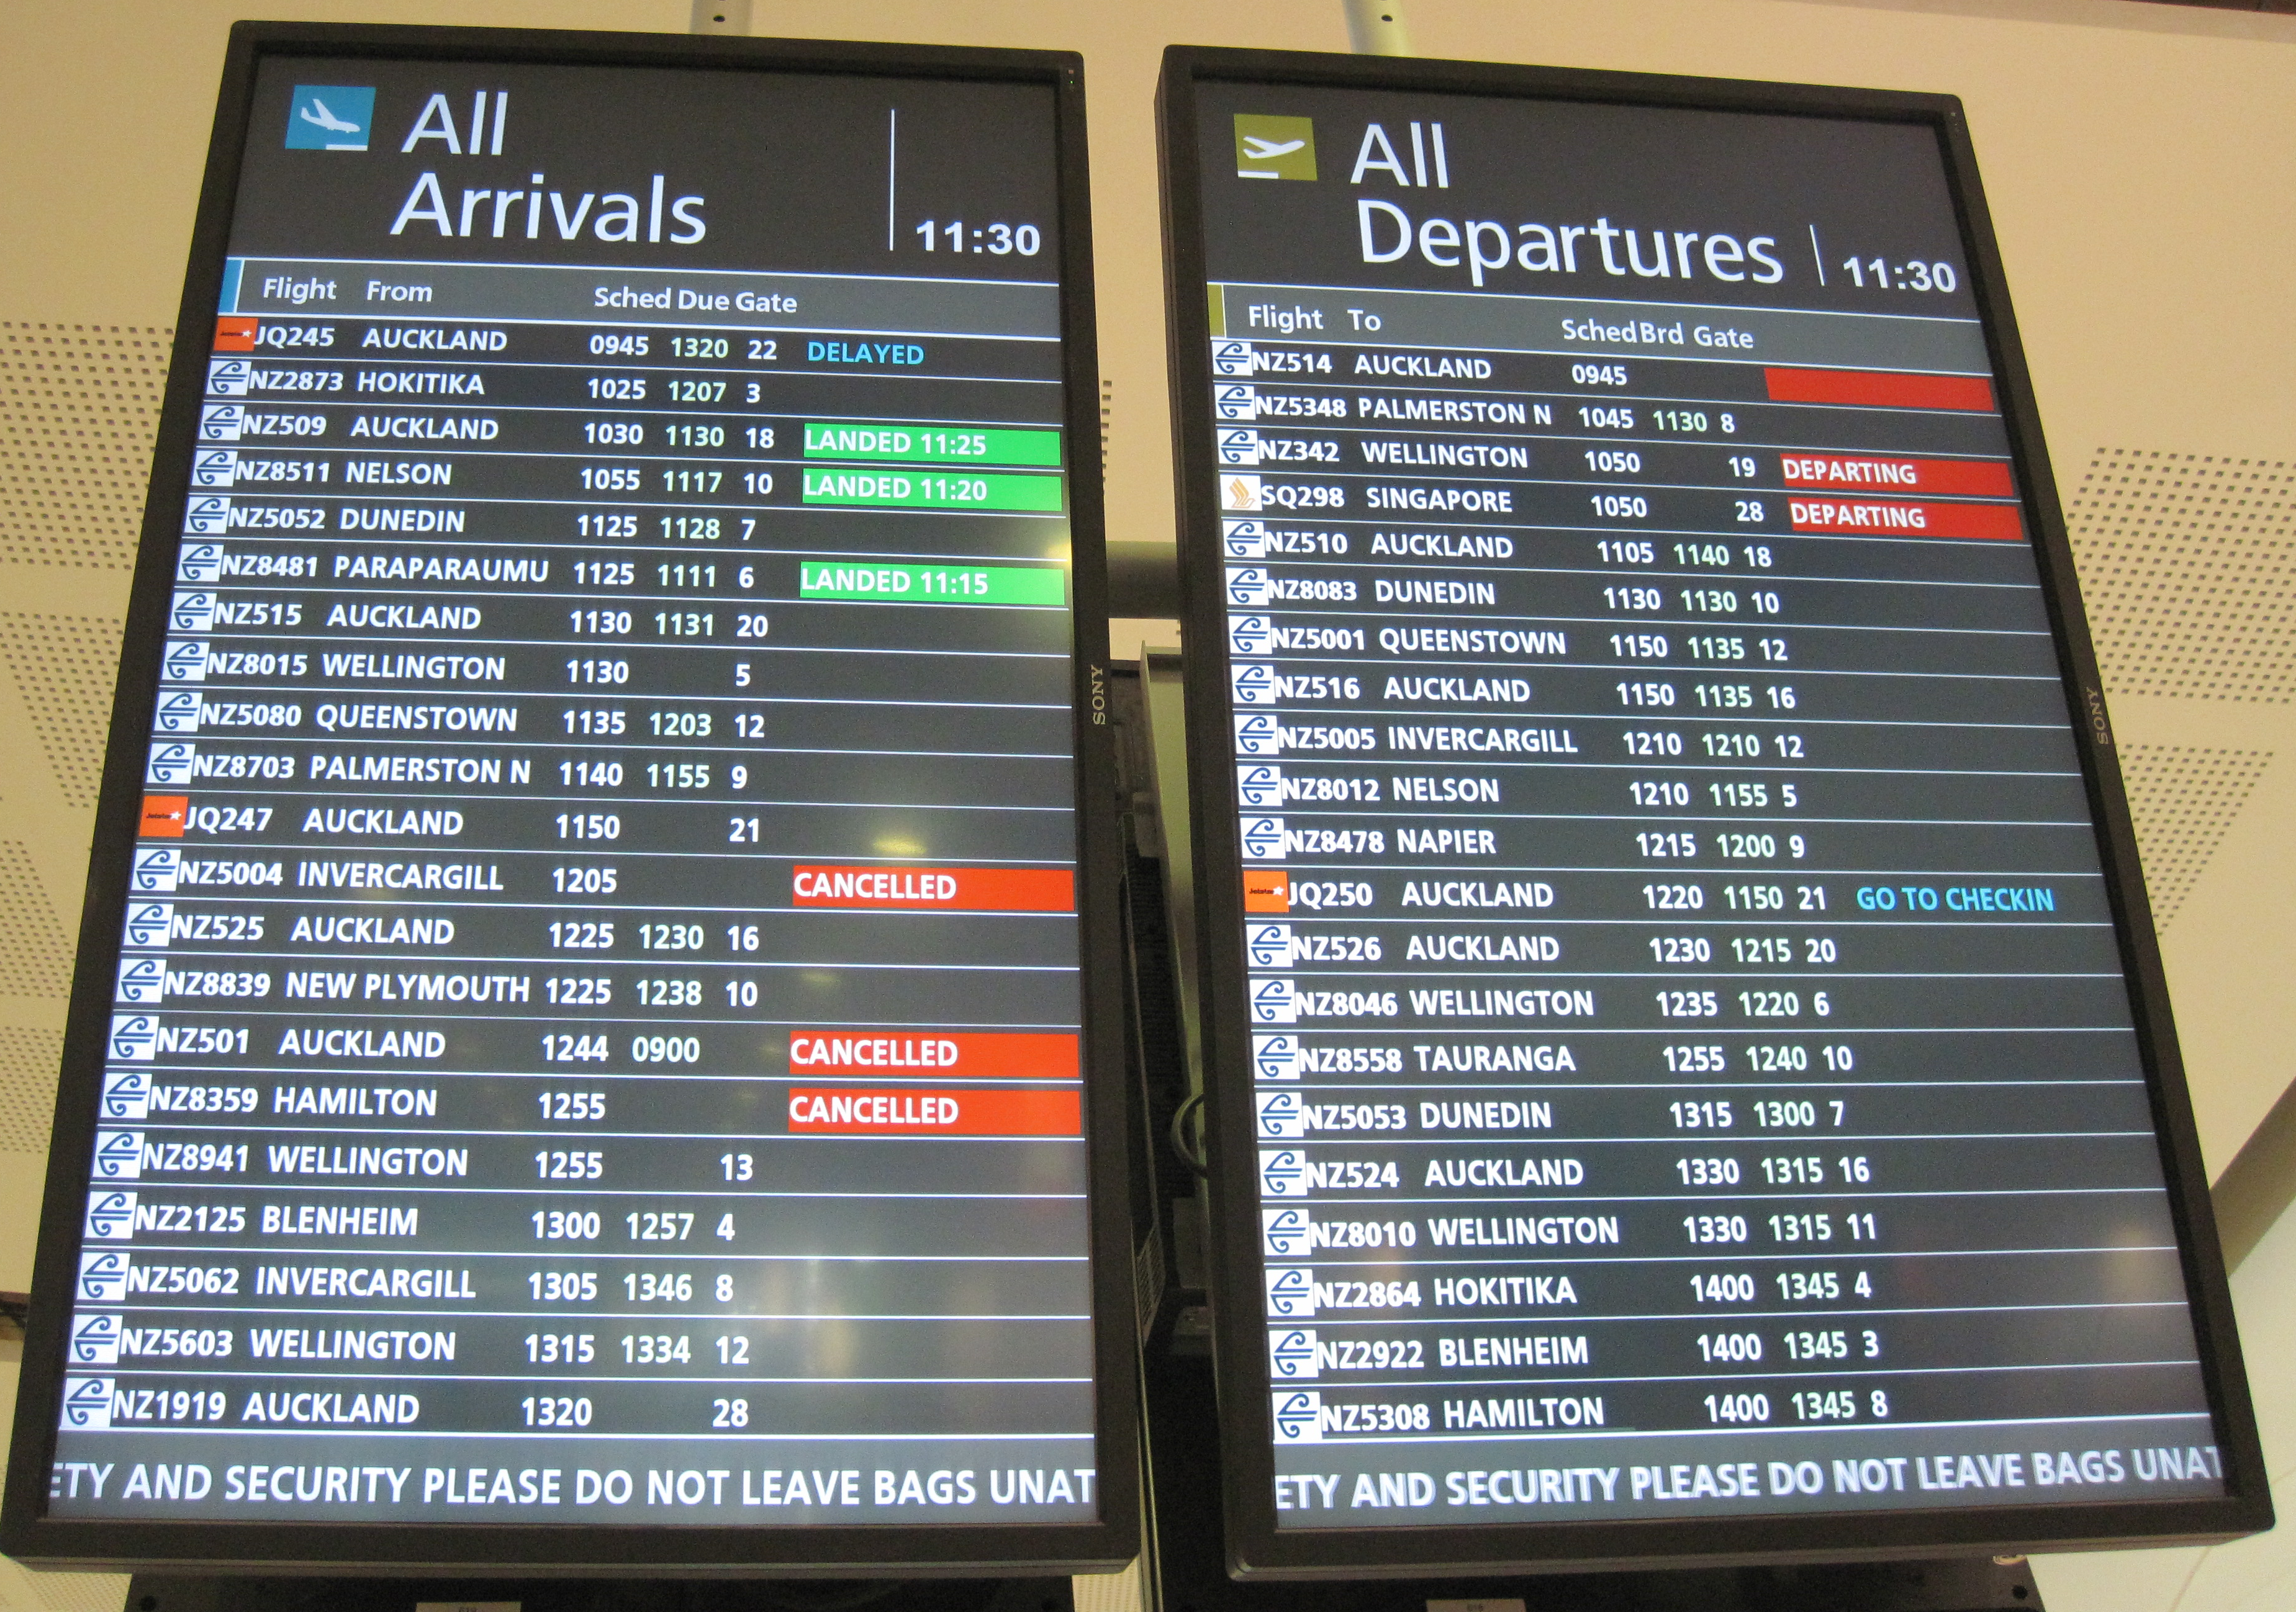
- What time was the photo taken?
- If you couldn’t read English, what visual cue is there for the difference between arriving and departing?
- How many flight items are shown on the Arrivals board?
- How many flight items are shown on the Departures board?
- How much time is covered in this photo of the Arrivals Board?
- How much time is covered in this photo of the Departures Board?
- How many flights arrive from Auckland?
- How many flights depart for Auckland?
- How many international flights are departing during this time?
- Name the places that have more than one flight arriving?
- Name the places that have more than one flight departing?
- How many different airlines have flights arriving?
- How many different airlines have flights departing?
- If you missed the first Auckland flight, how long after it is the next one?
- If you were to meet someone on the first flight in from Wellington and they were actually on the next one, what is the time difference?
- List all the different messages shown in the right column of the two boards. What other messages might be shown?
- How many flights arrived on time?
- What is the most common amount of time between Shed (scheduled departure) and Brd (boarding time)?
- Extra questions for discussion:
  - Why are words shown in all-caps when that could be harder to read than mixed-case?
  - How is colour used on the boards?
  - Look at the flight codes. What patterns can you see?
  - Why are times shown in military format?
  - Look at the gate numbers. What patterns can you see and speculate why that might be?
  - If you had the job of redesigning the boards, what changes would you suggest, if any?
  - Why might mathematicians analyse some of the data shown over a days/weeks/months/years?
  - What suggestions do you have for using technology to improve the user’s experience regarding arrivals and departures?

