DISASTERS
THE NEW ZEALAND FILM ARCHIVE
NGA KAITIAKI O NGA TAONGA WHITIAHUA

Formative Assessment Activity Level 2

Canned Disaster
This exercise is designed to encourage you to show how you could manage a natural disaster in New Zealand.

Instructions
Choose one of the following extreme natural events:

a) Earthquakes b) Volcanic Events c) Flooding.

Imagine that the extreme natural event you have chosen is contained in a tin can. Your task is to design a label to fit around the can (650 – 700 gram size).

- The label must clearly show the type of extreme natural event it contains.
- Think up a catchy name for the canned extreme natural event (eg Nasty Napier 1931).
- You should include other information which is found on can labels such as “contents” or “ingredients” or “directions for use” or “product of…”
- Your directions must clearly explain how a person can increase or decrease the likelihood or effects of the extreme natural event both in the short and long term.
- When you have finished making your label, glue it carefully to an old clean tin can and bring it to school to show your teacher.

The design of the label should grab people’s attention, just as any good advertising does. Check out labels on some canned food for ideas on use of colour, layout, lettering and design etc. Some examples of students’ work are shown below to give you some inspiration.

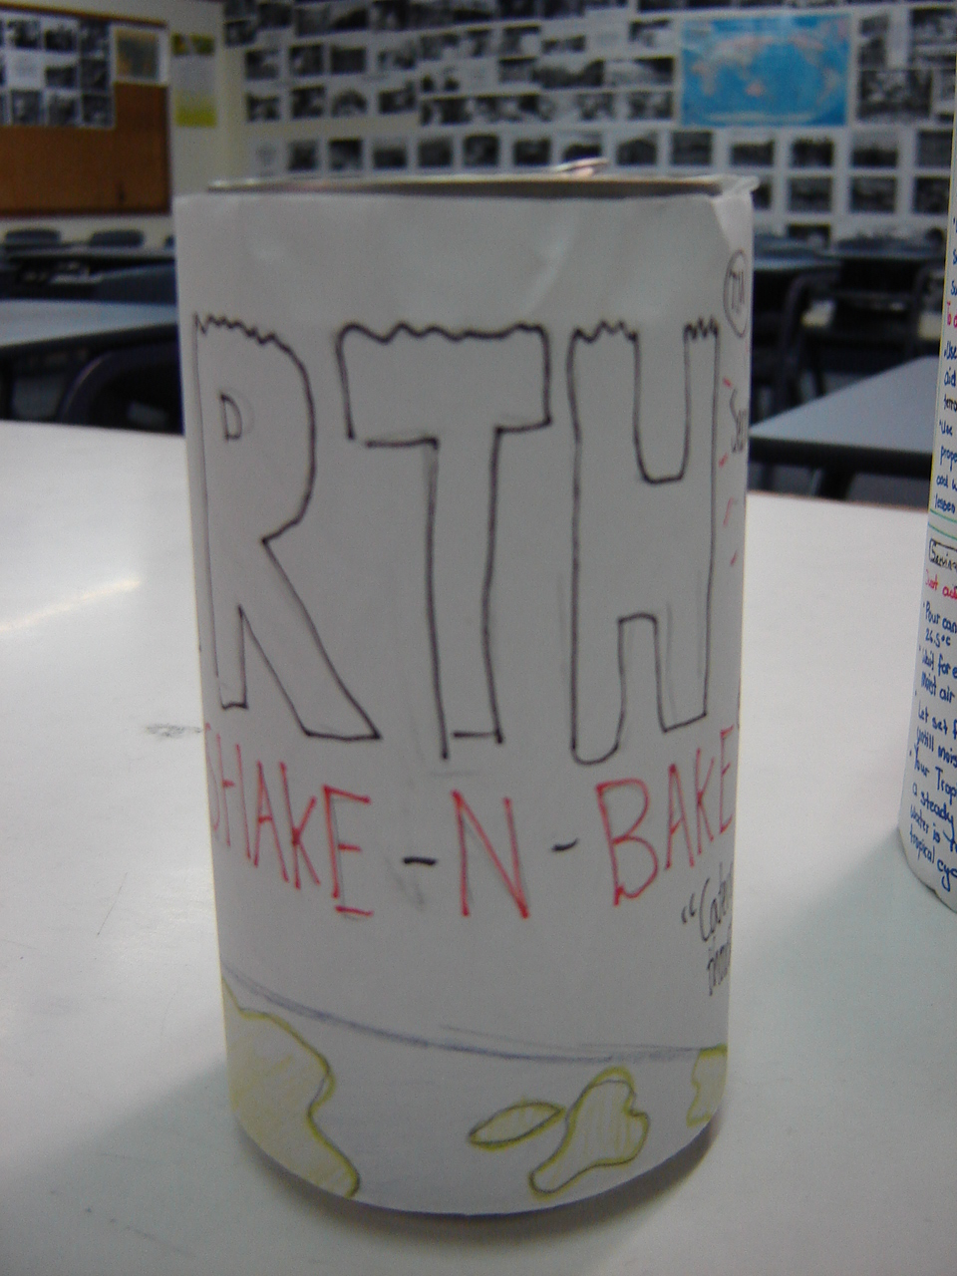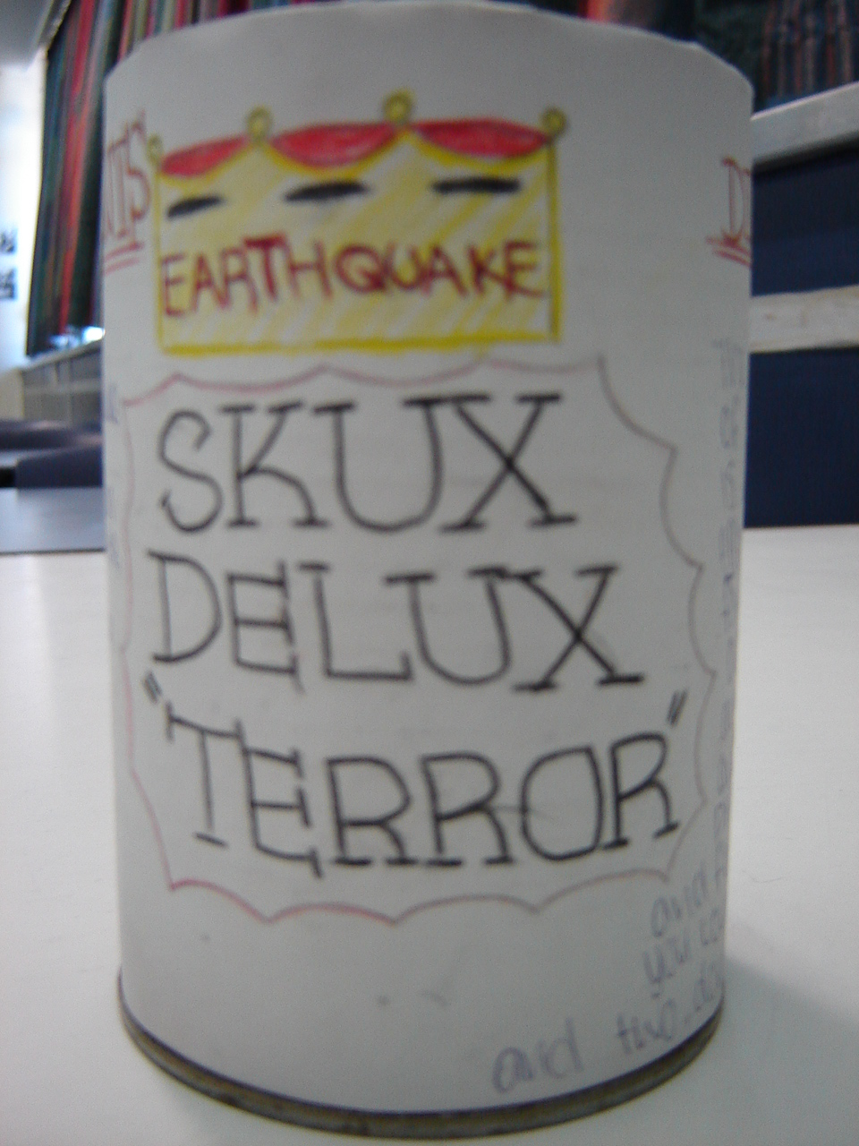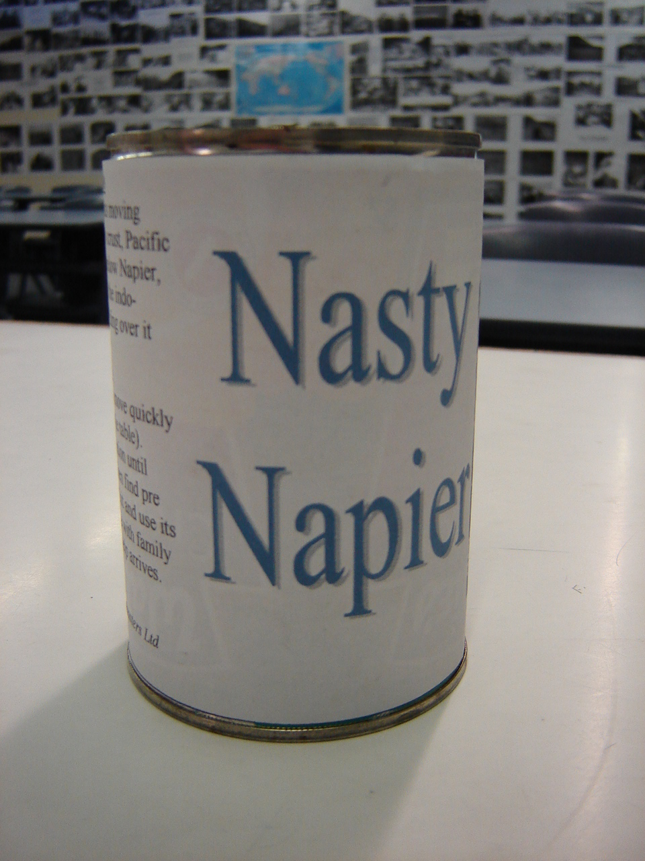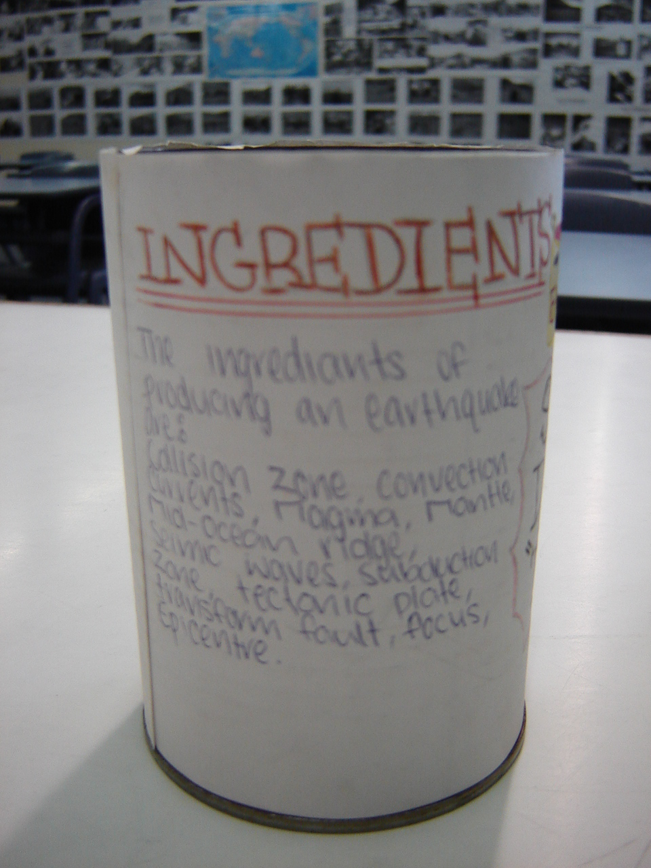

Be creative and have fun!

The complete canned disaster exercise is due on:
Canned Disaster - Assessment Criteria
Achieved | Merit | Excellence
The student has…  - Described the ingredients of the disaster.  - Told people how they can increase or decrease the effects of the disaster.  - Included a heading, illustrations, and colour. | The student has…  - Described the ingredients of the disaster in breadth or detail.  - Told people how they can increase or decrease the effects of the disaster in breadth or detail.  - Included a heading, illustrations, and colour. | The student has…  - Clearly described the ingredients of the disaster in breadth and detail.  - Told people clearly how they can increase or decrease the effects of the disaster in breadth and detail in the long and short term.  - Included a heading, illustrations, and colour.  - An element of creativity is evident.

