Curriculum Area:  Science Level 1 & 2 |  | Strand:  Planet Earth and Beyond | Background Page:  Wetlands of Ō Tū Wharekai
Achievement Aims: | Earth Systems - Levels 1-2: Explore and describe natural features and resources.

Look at the pictures of this ephemeral tarn and answer the questions.
1
2
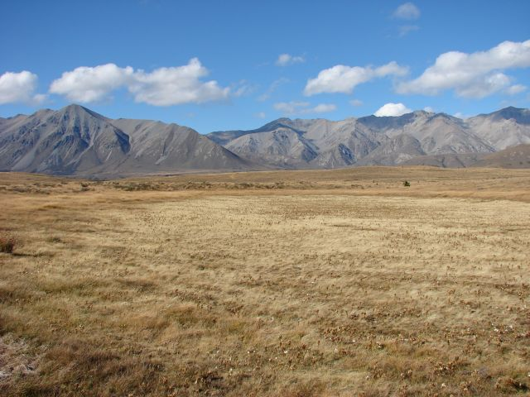
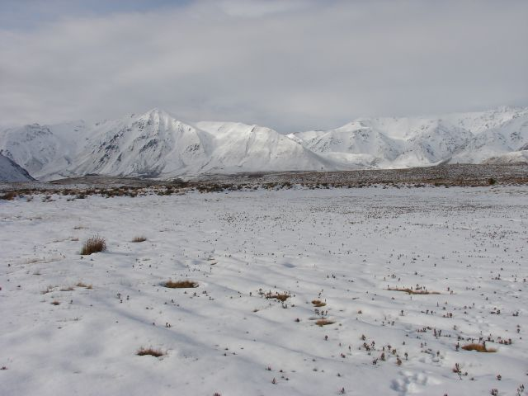
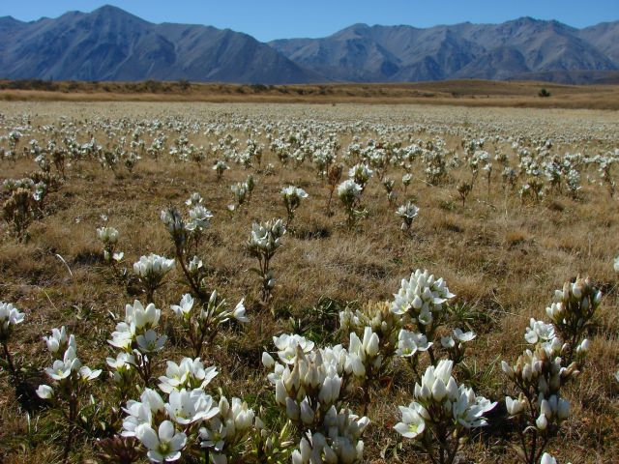
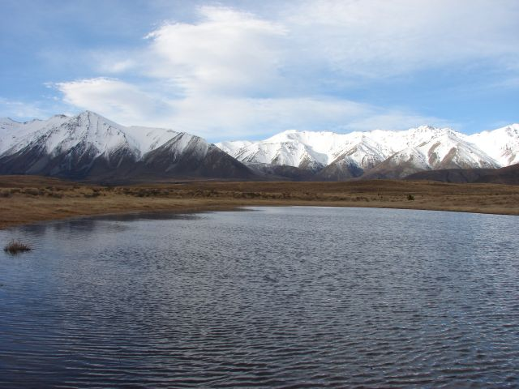
3
4
- Look at the photos. List all the different things you can see.

___________________________________________________________________

___________________________________________________________________

- What season does each photo show?

1 _______________

2 _______________

3 _______________

4 _______________

- What has happened to the water in each photo?

1 _______________________________________________________________

2 _______________________________________________________________

3 _______________________________________________________________

4 _______________________________________________________________

- If you were a wetland animal, which photo would you prefer to live in? Why?

_____________________________________________________________________

_____________________________________________________________________

