Curriculum Area:  Science Level 3 & 4 |  | Strand:  Planet Earth and Beyond | Background Page:  Wetlands of Ō Tū Wharekai
Achievement Aims: | Earth Systems - Levels 3-4: Appreciate that water, air, rocks and soil, and life forms make up our planet and recognise that these are also Earth’s resources.

Look at the pictures of this ephemeral tarn and answer the questions.
1
2
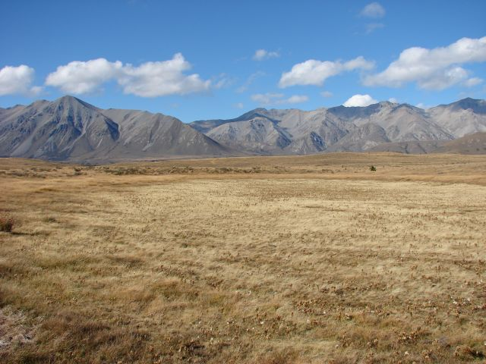
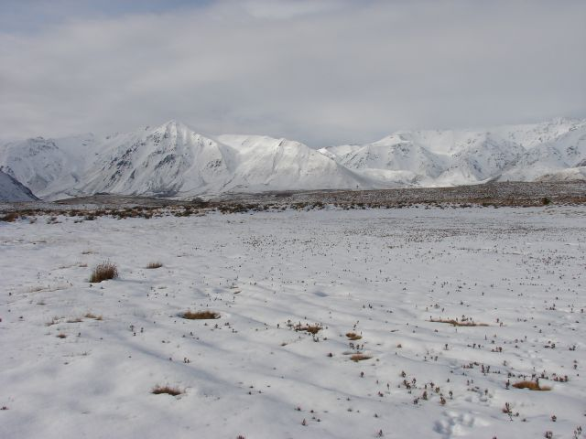
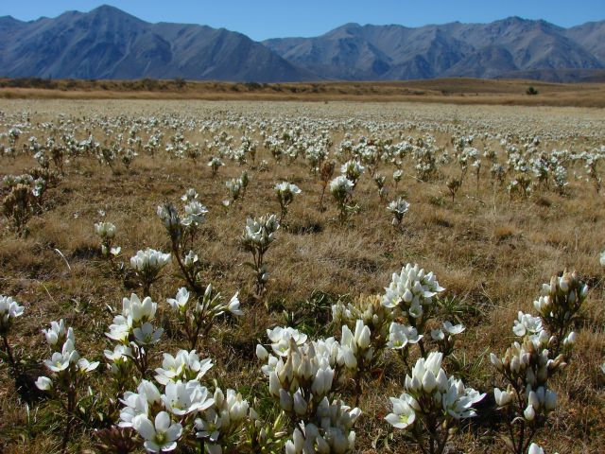
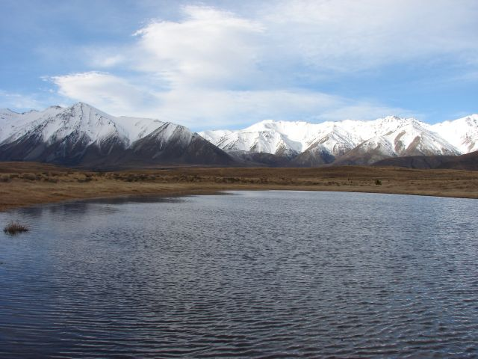
3
4
- Compare the photos.
- What are the main differences? _______________________________________

________________________________________________________________

- What has caused this change? _______________________________________

________________________________________________________________

- What other differences can you see? __________________________________

________________________________________________________________

- For each photo, say what season you think it is, what happens to the water and why.
- ______________________________________________________________

______________________________________________________________

______________________________________________________________

- ______________________________________________________________

______________________________________________________________

______________________________________________________________

- ______________________________________________________________

______________________________________________________________

______________________________________________________________

- ______________________________________________________________

______________________________________________________________

______________________________________________________________

- If you were a wetland animal, which photo would you prefer to live in? Why?

_____________________________________________________________________

_____________________________________________________________________

_____________________________________________________________________

