Freshwater Facts | Curriculum Area:  Mathematics and Statistics, Level 3/4 |  | Strands:  Number and Algebra, Geometry and measurement | Background Pages  A Precious Resource | Threats to Ecology – Introduced Weeds and Fish
Achievement Objectives: |  | Use a range of additive and simple multiplicative strategies with whole numbers, fractions, decimals, and percentages.  Use linear scales and whole numbers of metric units for length, area, volume and capacity, weight (mass), angle, temperature, and time.
Learning Intention: |  | Students will be able to solve problems and conduct statistical investigations based on a selection of Standard Background Pages from the LEARNZ Freshwater Ecology web site.
Thwart the Threat
Check clean dry is about stopping the spread of pest plants. For the clean part, your gear needs to be soaked in water that has either 5% detergent or 2% bleach.
- If a bucket holds about 8 litres of water, how much detergent do you need to put in? How much bleach?
detergent = _______ml bleach = ______ml
Wai Share?
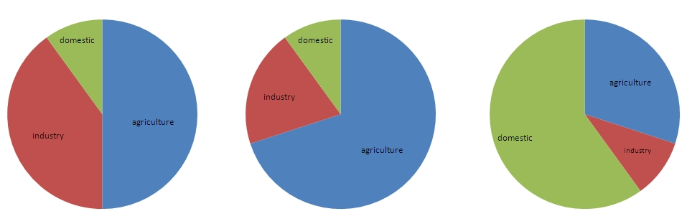
- Here are three graphs showing the three main ways that freshwater is used in the world. Have a look at the background reading page called ‘’A Precious Resource’ and circle the graph you think best shows how people use water.

- Use shading to show the percentages of human water use below. Label with A (agriculture), I (industry), and D (domestic).

Slim Chances
An average hen (female trout) lays 3000 eggs when spawning in the Tongariro River. Over the next three years, only 3 of these eggs will survive to run the river and spawn as a maiden fish.
- What reasons can you give for the rest of these trout not surviving?
______________________________________________________
____________________________________________________________________________________________________________
- There is only a 1 in __________ chance of surviving into adulthood as a maiden fish. What percentage is this?
_________%
- 60,000 trout run the Tongariro River each year. One in four are caught by anglers. How many trout are caught in the Tongariro each year? What percentage of 60,000 is this?
_______________ are caught each year. This is _________%

(Figures courtesy of DOC)

