Earthlearningidea
Waves in the Earth – Human Molecules

Pupils are pushed around to demonstrate the properties of seismic waves!

The P and S waves produced by earthquakes are transmitted in different ways through solids and
fluids. This can be visually demonstrated using human molecules’. Ask four or five pupils to stand in a row, with their hands on each others’ shoulders, and their arms held rigidly, as shown in the photograph.
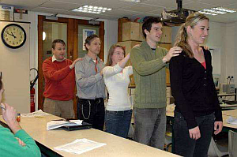
“Human molecules” representing a P wave being transmitted through a solid (Photograph courtesy of the Earth Science Education Unit, Keele University)

They should keep their arms straight and hold on firmly to the person in front. Explain that they represent the molecules in a solid, which are strongly bonded together. Ask the pupil at the back to apply a gentle push-pull motion to the pupil in front.

Do this several times and watch the “wave” pass down the line of pupils. Each pupil should end up in the same position as at the start. This represents a P wave and it models the way in which an earthquake may generate a wave capable of passing through solid parts of the Earth’s interior. Now ask the pupil at the back to shake the others gently from side to side and produce a different sort of wave passing along the line. This is an S wave and it too would be triggered by the same earthquake. The demonstration shows that, like the P wave, it is also capable of passing through the solid parts of the Earth’s interior.

Now ask pupils to drop their arms, to represent the molecules in a fluid (a liquid or a gas). A pupil should move the rearmost pupil from side to side to model the way in which an S wave may be initiated by an earthquake. However, it will not now pass down the line of pupils, demonstrating that an S wave is not transmitted through a fluid. Ask pupils to close up so that they are almost touching each other, but with their arms still at their sides. Warn the front pupil to expect a surprise, then ask the rearmost pupil to give a gentle shove. This will produce a “P wave” passing along the row, although the pupils do not always bounce back again as the real molecules would! This shows that a P wave can be transmitted through a fluid (liquid or a gas), in contrast to the S wave demonstrated above. (See photograph below)

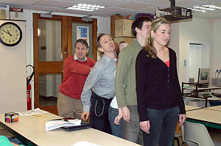
“Human molecules” taken by surprise as a P wave is transmitted through a “fluid” (Photograph courtesy of the Earth Science Education Unit, Keele University)
………………………………………………………………………………………………………………..…
The Back Up
Title: Waves in the Earth 2 – Human molecules
Subtitle: Pupils are pushed around to demonstrate the properties of seismic waves!
Topic: A demonstration of the properties of seismic P and S waves, which is most effective when the slinky demonstration has been carried out first (See Earthlearningidea activity ‘Waves in the Earth 1 - The slinky simulation’).
Age range of pupils: 14 – 18 years
Time needed to complete activity: 10 minutes
Pupil learning outcomes: Pupils can:
- simulate the different behaviour of solids and fluids when subjected to stress;
- explain that fluids (e.g. liquids) cannot transmit S waves whilst solids can do so.

Through the follow up activity, pupils can:
- describe the shape of a graph of wave velocities versus depth in the Earth;
- explain the shape of this graph.
Context:
This demonstration can be used in the context of a lesson on wave motion for its own sake, or, as here, in explaining how seismic waves can be used to show the nature of the interior of the Earth.

Earthlearningidea

Follow up activity:
Ask pupils to study the graph below. Invite them:
a) to describe the changes of velocity of the P waves and of the S waves with increasing depth in the Earth
b) to explain why the S wave velocity decreases to zero at a depth of about 2900 km.
c) to suggest why the wave velocity decreases slightly at a depth of about 100 km, before
increasing again.

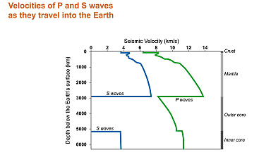
Diagram showing the relationship between seismic wave velocity and depth in the Earth, from the surface to its centre. (by permission of the Earth Science Education Unit, Keele University)

Underlying principles:
- Earthquakes are generated within the top 700km or so of the crust and mantle by brittle failure of rock masses.
- Earthquake waves are transmitted by elastic deformation, i.e. particles oscillate forwards and backwards and from side to side but return to their original positions.
- P and S waves can pass through the body of the Earth and are therefore collectively known as body waves.
- S waves cannot be transmitted through a fluid (eg. a liquid) because they depend on the shear strength of the medium through which they are travelling. The shear strength of a fluid is zero.
- Seismic wave velocity decreases between about 100 and 250 km below the surface, indicating that there is a small amount of liquid between the crystals of the rocks at that depth. No more than about 5% of the mantle in this zone is liquid.
- S waves are generated in the inner core (by P waves), showing that it is solid. None of these S waves can get back to the surface through the liquid outer core, but they can trigger further P waves as they reach the boundary between the inner and outer core. (This may be demonstrated using two slinky springs, one connected at right angles to another).

Thinking skill development:
Pupils establish a pattern of the behaviour of “molecules”. Cognitive conflict arises when the “S
wave in a liquid” is demonstrated (pupils invariably turn round to see what is about to happen!). Applying the pupil molecule demonstration to the real Earth demands bridging skills.
Resource list:
• four or five willing pupils!
• For following up the activity, a copy of the graph for each pupil or group of pupils

© Earthlearningidea team. The Earthlearningidea team seeks to produce a teaching idea regularly, at minimal cost, with minimal resources, for teacher educators and teachers of Earth science through school-level geography or science, with an online discussion around every idea in order to develop a global support network. ‘Earthlearningidea’ has little funding and is produced largely by voluntary effort.
Copyright is waived for original material contained in this activity if it is required for use within the laboratory or classroom. Copyright material contained herein from other publishers rests with them. Any organisation wishing to use this material should contact the Earthlearningidea team.
Every effort has been made to locate and contact copyright holders of materials included in this activity in order to obtain their
permission. Please contact us if, however, you believe your copyright is being infringed: we welcome any information that will help us to update our records.
If you have any difficulty with the readability of these documents, please contact the Earthlearningidea team for further help.
Contact the Earthlearningidea team at: info@earthlearningidea.com

