Curriculum Areas:  Science Level 1 & 2 |  | Strands:  Living World | Background Page:  Braided Rivers
Achievement Aims: | Ecology - Level 1-2: Recognise that living things are suited to their particular habitat.  Earth Systems - Level 1-2: Explore and describe natural features and resources.

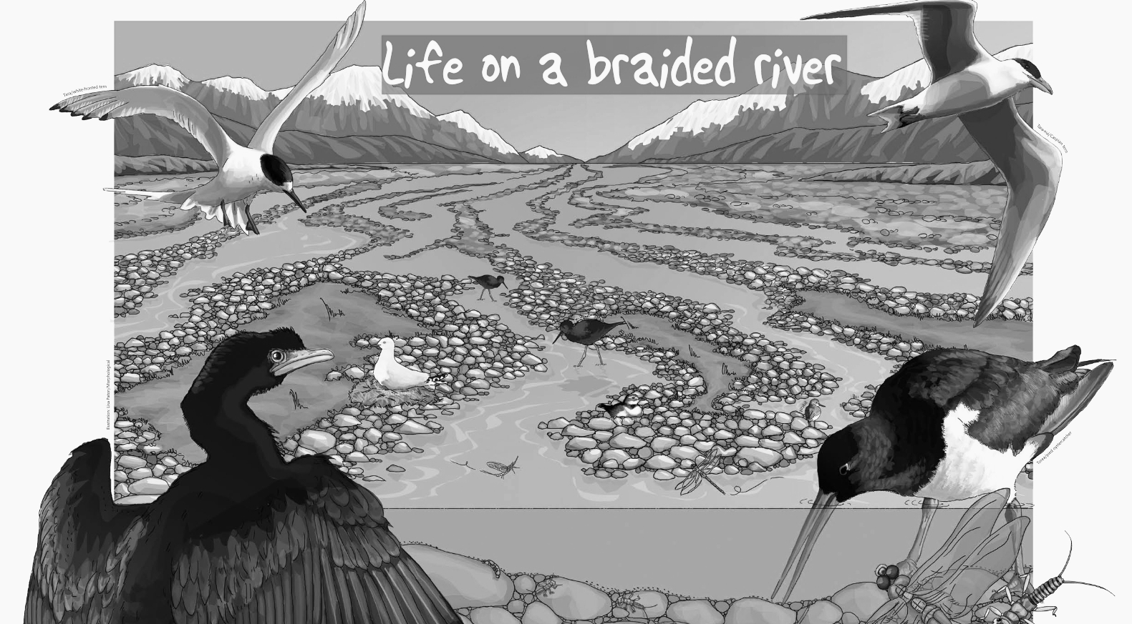
Below are five sentences about this picture. Put the number of each sentence into the boxes you can see that would best describe what is happening in that particular part of the picture.

- Rocks that fall down mountainsides end up in rivers. When the slope of the river flattens out on the plains, the rocks are set down.
- Braided rivers are made when rocks and sediment build up on a riverbed.
- About 26 bird species feed and breed on our braided rivers e.g. kakī/black stilts.
- A few seabird species breed along braided rivers too e.g. Tarāpunga/black-billed gull.
- Braided rivers and wetlands are home to many aquatic invertebrates.

