STUDENT ACTIVITY: New Zealand plate boundary models

Activity idea

In this activity, students make and/or observe two 3D moving models of the different tectonic plate boundaries under the North and South Islands representing the North Island subduction zone and the South Island Alpine Fault.

By the end of this activity, students should be able to:
- understand the movement of plate boundaries in different parts of New Zealand.

This activity was developed for the Earthquake Commission (EQC) and has been kindly provided for use on the Science Learning Hub.

Introduction/background
What you need
What to do
Making the North Island subduction zone model
Making the South Island fault model
Using the North Island subduction zone model
Using the South Island fault model
Model pieces

Introduction/background

The 3D, highly dynamic nature of plate boundaries can be hard for students to comprehend, so these models make visualisation easier.
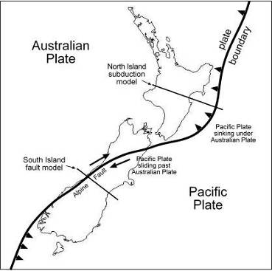
The New Zealand plate boundary

New Zealand is on the boundary between the Australian and Pacific tectonic plates. These two plates are being pushed towards each other, but with different results in different parts of New Zealand.

To the east of the North Island is a subduction zone, where the Pacific plate plunges down under the Australian plate.

The North Island subduction zone model gives an idea of what is happening here, along the line marked on the map.

South of the South Island seems to be another subduction zone, where the Australian plate pushes down under the Pacific plate.

In between, there is no subduction, but the two plates meet at a major fault, where two parts of the South Island are sliding past each other. At the same time, the eastern part is being pushed upwards. The South Island fault model gives an idea of what is happening here, along the line marked on the map.

What you need

- Instructions for making the North Island subduction zone model
- Instructions for making the South Island fault model
- Pages for the foam board pieces (2 pages for the North Island subduction zone and 1 page for the South Island fault) printed onto ordinary photocopy paper (80gms), then pasted (spray glue is ideal) onto 5mm white foam board (a white foam core sandwiched between layers of paper – very easy to cut)
- Pages for the paper pieces (2 pages for the North Island subduction zone and 1 page for the South Island fault) printed onto thick paper (120 or 140gms)
- Craft knife
- Metal ruler
- Cutting mat
- PVA glue
- Piece of soft, flexible paper or fabric – 70mm x 70mm

What to do

- Follow the instructions in Making the North Island subduction zone model and Making the South Island fault model using the Model pieces. The models can take a while to make, so students could work in twos or threes, building one component each. Alternatively, the teacher could make one of each model beforehand to use as a demonstration.

- Follow the instructions in Using the North Island subduction zone model and Using the South Island fault model to demonstrate what is happening at the different tectonic plate boundaries.

Making the North Island subduction zone model

- On the printed sheets, a number in a circle is the piece number.
- On some pieces are areas enclosed by dotted lines. These indicate where a piece needs to be glued – a number (not circled) refers to the piece to be attached.
- Cut out and glue as accurately as you can.
- When cutting straight lines, use a metal ruler as a guide.
- Keep the knife vertical when cutting foam board.
- Don’t over-do the glue!

- Assemble base and Pacific plate

- Cut out foam board pieces 1–5 and paper piece 6.
- Glue long bottom edges of 2 and 3 to marked places on 1 (the printed side should be facing out). Make sure these two pieces are vertical and the straight ends are flush with the end of 1.
- Glue 4 onto the end of the structure.
- Glue one edge of 5 onto the place marked on 4 – put some glue on the ends too, and attach flush to 2 and 3.
- Glue paper piece 6 to 5 and curved edges of 2 and 3

- Assemble the Oceanic crust

- Cut out foam board pieces 7–11 and paper pieces 12 and 13.
- Lay piece 7 printed side down and attach other pieces.
- Lay the structure on the table, with words ‘Oceanic crust’ up the right way.
- Put glue on all exposed edges of foam board, and fix on paper piece 12.
- Turn structure over and glue on paper piece 13.

- Assemble the Australian plate

- Cut out foam board pieces 14–17 and paper pieces 18 and 19.
- Lay piece 14 printed side down.
- Glue on a long edge of 15.
- Glue on end of 16.
- Glue 17 to 15 and 16.

- Place structure upright on table.
- Glue paper piece 18 (printed side up) onto top edges of 14–17. Make sure the blue part of 18 lines up with the blue part of 17.
- Glue paper piece 19 onto 16 and lower curved edges of 14 and 17.

- Putting it all together

- Place the Oceanic crust on top of the curve of the Pacific plate. The Hikurangi Trench should be nearer the top.
- Glue the bottom of the Australian plate structure on to places marked 14, 15 and 17 on base. You may need to adjust the exact position of the Australian plate so that it traps the Oceanic crust firmly against the Pacific plate. The Oceanic plate should stay at the top of the slope and only move down when pushed.
- Take the piece of 70 x 70mm soft paper or fabric, and fold over 5mm of one side – make a sharp crease.
- Glue this tab between the dotted lines marked ‘Accretion wedge’ on the Australian plate. Don’t let glue spread outside this area.
- Glue the other end of the soft paper between the dotted lines marked Hikurangi Trench on the Oceanic crust. Keep glue between the dotted lines.
- Cut out the two small foam board volcanoes (pieces 20) or make your own volcanoes. Place these in the Taupo Volcanic Zone.

Congratulations, you have now finished your model of the subduction zone beneath the North Island of New Zealand.

Making the South Island fault model

- Assemble base

- Cut out foam board pieces 1–4 and paper piece 5.
- Place piece 1 print side down on table.
- Glue on pieces 2 and 3 – make sure they are vertical and flush with edges.
- Glue 4 to 2 and 3.

- Score along the two dotted lines on 5. (One may be hard to see – it is along the edge of the coloured image.)
- Fold piece as shown on right.
- Place base structure upright on table, and glue piece 5 to upper edges.
- Assemble the separate block

- Cut out foam board pieces 6–9 and paper piece 10.
- Place 6 printed side down on table.
- Glue on 7 and 8.
- Glue 9 to 7 and 8.
- Score along the two dotted lines on 10. (One may be hard to see – it is along the edge of the coloured image.)
- Fold piece as shown.

- Glue this piece to the edges of the structure made just before this. You may find it easier to glue the long section first, rather than trying to do all three at once.

- The structure should now look like this. Put this block on the base to complete the model

Using the North Island subduction zone model
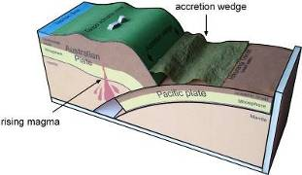
- Move the Pacific plate to the top of the slope. Note that the whole plate is below sea level.

- Move the Pacific plate slowly down the slope. As the crust gets deeper, temperature and pressure increase, causing rock to melt. The melted rock (magma) rises and comes to the surface at volcanoes and thermal areas.

The movement of the oceanic crust is very slow (about 5cm a year) and is not smooth. It can become locked with the continental crust, and stresses build up until the energy is suddenly released as an earthquake.

In the model, the Pacific plate is a fixed size, so as it moves down, a gap opens up behind it. In reality, the oceanic crust is continuously being formed through seafloor spreading from the central Pacific.

- Now move the Pacific plate back to the top, then again slowly down the slope, under the continental crust. This time, watch what happens to the soft paper piece marked ‘accretion wedge’.

The accretion wedge is made of layers of sedimentary rock on the east coast of New Zealand. In real life, it is solid, not hollow like the one in the model. The mass of the continental crust acts like a bulldozer and scrapes off the sedimentary rocks laying on top of the oceanic crust as it goes underneath. These rocks become deformed and scrunched up, so some of the accretion wedge rises above sea level.

Examples of these scraped up rocks can be seen in Hawke’s Bay, at Te Mata Peak and Cape Kidnappers.

Using the South Island fault model
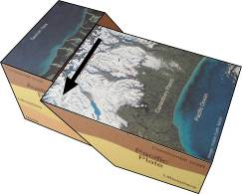
Continental crusts of the Pacific and Australian plates meet under the South Island, at what is called the Alpine Fault.

- Set the model up so that the loose block sits neatly on the base, with the words ‘Pacific Ocean’ closest to you. Note that rivers (white lines) flow across the fault from the Southern Alps to the Tasman Sea.

- Now slide the block about 15mm to the left, as shown on the right.

What has happened to the rivers?

The east side of the Alpine Fault slides past the west side like this, only about 35mm a year. The movement is not smooth – there are big jumps about every one to two hundred years, accompanied by big earthquakes. Kinks in rivers tell us that these jumps may be up to 8m.

A fault with just sideways movement like this is called a strike-slip fault.

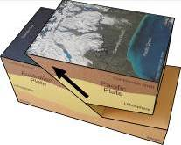
- Reset the model.

- Now push the block towards the Tasman Sea, so that it rises, as shown on the right. You could use some spare foam board under the block to keep it in position.

As well as the sideways movement, the east part of the South Island is also being pushed up over the west part, at a rate of about 7mm a year. However, the Alps don’t just get higher and higher, as they are being constantly eroded away.

A fault with upwards movement like this is called a reverse fault.

The Alpine Fault, which combines both movements, is called an oblique-slip fault.

- Reset the model and move the block so that it moves sideways and upwards at the same time, like the Alpine Fault.

