LEARNZ Virtual Field Trip
An Example of a Planning Sequence

This example of a short-term lesson sequence for primary schools makes use of all field trip components for a 3-day virtual field trip.

However, the flexibility of LEARNZ means that teachers can use as many or as few of the components as they wish. Teachers who are involved for the first time may wish to choose just one or two.

Teachers, visit the Support Section of the LEARNZ website for more information on:
- Getting started with LEARNZ
- The ambassador programme
- Taking part in audioconferences
- Ask-an-Expert web forum

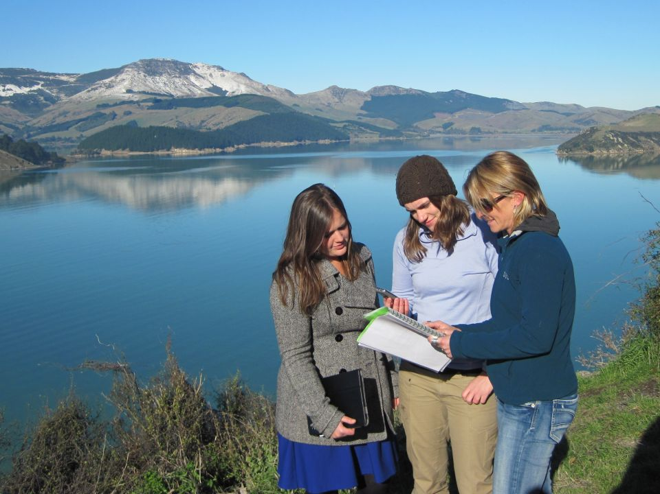
This plan includes the following components of a LEARNZ Virtual Field Trip.

- planning using the online curriculum links
- using online and printable background information
- using online interactive self-marking plus other activities
- using daily field trip diaries with photos and inquiry questions
- using daily field trip video clips and inquiry questions
- using Twitter for live updates and information/thought sharing
- putting questions to experts during live audioconferences
- listening to audioconferences while completing related tasks
- taking part in the Backchannel during audioconferences
- completing audioconference summaries
- posting questions to the LEARNZ Ask an Expert Web Board
- sending a class ambassador, viewing the ambassador's daily web page updates
- corresponding by email with the LEARNZ teacher and the class ambassador
- completing a field trip evaluation

An Example of a Planning Sequence
Timeline | 6 weeks before field trip | 4 weeks prior |  | 2 weeks prior |  |  | Thursday |  |  | Friday |  | The week prior  Monday |  |  | Tuesday |  |  | Wednesday |  |  |  | Thursday |  |  | Friday
Suggested teacher and classroom activities | Decide to take a virtual field trip. Register with LEARNZ  Log onto MyLEARNZ and enrol class(es) in selected field trip(s) | Plan the field trip to fit with class, term and year plan.  Select AOs.  Send class login home with students so parents can follow field trip. |  | Plan field trip (3-4 weeks) into your daily timetable  Select background pages and activities for class/group sessions.  Plan to ask questions in audioconferences.  Plan to listen to others |  |  | Set scene with class - "Let's go on a field trip to ... What might we see, what could we find out? ..."  Introduce field trip location and themes, guests, website material.  Create field trip display in classroom. |  |  | Develop questions about the audioconference topics |  | Read about the LEARNZ field trip teacher's ambassador.  Select class ambassador to send on trip.  Write up summary of ambassador's life plus hopes and dreams for field trip. |  |  | Develop and find answers for questions about audioconference topic  Add ambassador photo to field trip display in your classroom. |  |  | Summarise the unanswered questions on the audioconference topics into 10 "fat" questions for each |  |  |  | Class prepares short assembly item to share with team, school or principal about their adventures next week.  Teacher checks audioconference equipment, calls another school or LEARNZ free phone 0800 22 55 53 to check sound quality, phone jacks, school phone system etc. If using Skype please test this with the LEARNZ team. |  |  | Present short assembly item.  Call another school or a parent and have class practise asking questions
 |  |  |  |  |  |  |  |  |  | During brainstorming, keep a chart of unanswered questions. Summarise later to form “FAT” questions to ask in your audioconference.
Teacher contact with LEARNZ team | Join LEARNZ group on VLN for this field trip, and get ideas from other teachers. | Receive newsletter #1 |  | Receive newsletter #2  Send email to book in to audioconferences including date, time  NB: ONLY speaking schools need to book, as they ask questions live. |  |  |  |  |  |  |  | Sign-up class ambassador online, include details from class discussion  Receive ambassador confirmation email with your ambassador's email address for the field trip.  Post ambassador to address supplied by LEARNZ Teacher in a personal email. |  |  |  |  |  | Email 10 "fat" questions for each audioconference topic to shelley.hersey@core-ed.org |  |  |  |  |  |  | Receive newsletter #3.  Receive confirmed audioconference questions to ask.  Receive email - ambassador arrived.
Online Material available | Complete Registration & Enrolment.  Review field trip Summary. | Web Site goes live.  Standard and easy background pages. Web Board opens for questions. |  | Audioconference timetable confirmed, expert profiles, locations. |  |  | Field trip website |  |  |  |  | Class ambassador pages |  |  |  |  |  |  |  |  |  |  |  |  | Audioconference questions online
 |  | Check home page of field trip for daily additions to the site
The LEARNZ Team is available for support, audioconference practise and general inquiries.
0800 22 55 53
An Example of a Planning Sequence (continued)
Timeline | Field trip week Monday |  | Tuesday |  |  | Wednesday |  |  | Thursday |  |  |  | Friday |  |  | First week after  Monday |  |  | Tuesday |  | Wednesday |  |  | Thursday |  |  | Friday
Suggested teacher and classroom activities | Finish off previous week’s field trip tasks and activities. Discuss expectations and hopes for field trip.  Print or bookmark questions for three days of audio conferences.  Students write to ambassador - combine into a single email and send.  Get live updates on Twitter – follow @andrewpenny01 + share/contribute with student tweets. |  | Read Mon diary.  Read Mon ambassador diary.  Find travel routes to field trip location on LEARNZ Homepage map.  Listen to today's audioconferences | Take part in Backchannel.  Write summary for today's audioconferences.  Ask questions in your booked audio-conference (Tue or Wed or Thu). |  |  | Read Tue diary.  Watch Tue videos, answer questions.  Read Tue ambassador diary.  Listen to today's audioconferences | Take part in Backchannel.  Write summary for today's audioconferences. |  |  | Read Wed diary.  Watch Wed videos, answer questions.  Read Wed ambassador diary.  Listen to today's audioconferences | Take part in Backchannel.  Write summary for today's audioconferences. |  |  |  | Read Thu diary.  Watch Thu videos, answer questions.  Read Thu ambassador diary.  Add unanswered questions to the Web Board? |  |  | Review expectations and hopes for field trip.  Create chart of highlights.  Create individual records of the trip - include images and experiences.  Add unanswered questions to the Web Board. |  |  | Create individual records of the trip - include images and experiences.  Read web board answers |  | Present individual records of the trip to class, team, assembly or parents.  Summarise trip for assessment. |  |  | Teacher completes online evaluation of the field trip, including student feedback. |  |  | Share learning online via blog or wiki or class web site. Publicise in school newsletter and/or BOT report.
Teacher contact with LEARNZ team |  |  |  |  |  | Send audioconference summary to LEARNZ Teacher – shelley.hersey@core-ed.org |  |  |  |  |  |  |  |  |  |  |  |  | Receive newsletter #4  Receive thank you for participating email and audioconference certificate
Teacher contact with LEARNZ team |  |  | Send email to ambassador  Receive reply from ambassador |  |  |  |  |  |  |  |  |  |  | Complete online evaluation form by due date to go into draw for evaluation prize. |  |  |  |  |  |  |  |  | Receive ambassador back in post with participation certificate.
Online Material available |  |  | Diary #1 Monday |  | Diary #2 Tuesday |  |  | Diary #3 Wednesday |  |  | Diary #4 Thursday |  |  | Review field trip components.  Audioconference summaries. |  |  | Review field trip components.  Audioconference summaries. |  |  | Field trip website.  Web Board answers. Audioconference summaries. |  |  | Field trip website.  Web Board answers.  Audioconference summaries. |  |  | Field trip website.  Web Board answers.  Audioconference summaries.
Online Material available |  |  | Ambassador update |  | Ambassador update  Videos with questions (answers in Resources)  Audioconferences – daily recordings
Online Material available | Check home page of field trip for daily additions to the site |  |  |  |  |  |  |  |  |  |  |  |  |  |  |  |  |  |  |  |  |  | Fourth week after  Receive newsletter #5.  Evaluation Prize winner drawn  Web Board is locked and archived on field trip site - no new topics.  Choose next field trip, enrol class.
The LEARNZ Team is available for support, audioconference practise and general inquires.
0800 22 55 53

