DISASTERS
THE NEW ZEALAND FILM ARCHIVE
NGA KAITIAKI O NGA TAONGA WHITIAHUA

Formative Assessment Activity Y 9-10

Civil Defence Poster

Using the information and ideas presented to you in the film footage, design a large eye catching Civil Defence poster that informs people how to prepare for and protect themselves and their property from a natural disaster.

Choose from either:
  - Earthquakes
  - Volcanoes
  - Flooding
  - High winds

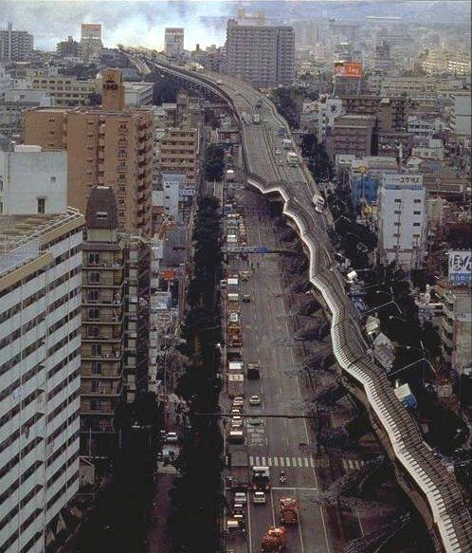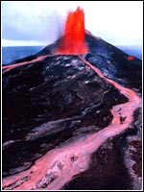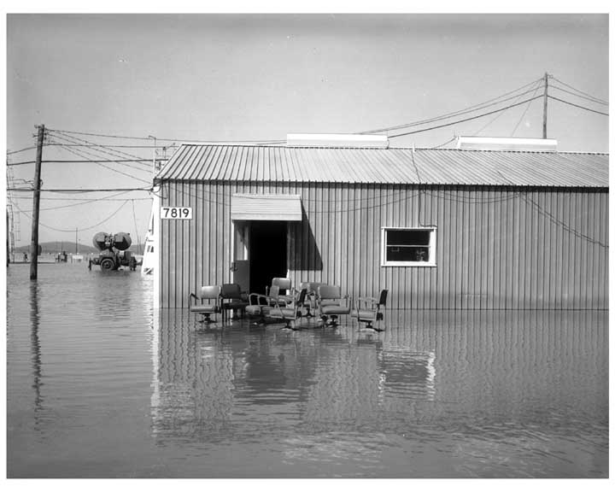

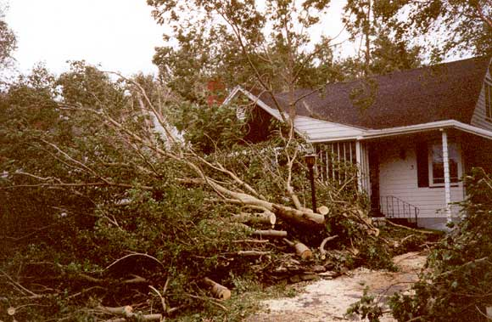

Your poster should have a large heading and illustrations, use colour, and have three short paragraphs of written information on it.

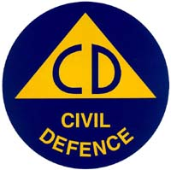

The poster is due on:

Civil Defence Poster - Assessment Criteria

Achieved | Merit | Excellence
The student has…  - Informed people how to protect themselves and their property from a disaster.  - Included a large heading, illustrations, colour, and has at least one short paragraph of written information. | The student has…  - Clearly informed people in breadth or detail how to protect themselves and their property from a disaster.  - Included a large heading, illustrations, colour, and has at least two short paragraphs of written information. | The student has…  - Clearly informed people in breadth and detail how to protect themselves and their property from a disaster.  - Included a large heading, illustrations, colour, and has at least three short paragraphs of written information.  - An element of creativity is evident.

