Curriculum Area:  Science Level 1/2 |  | Strand:  Planet Earth and Beyond | Background Page:  The Water Cycle
Achievement Aims: | Interacting systems  Levels 1-2: Describe how natural features are changed and resources affected by natural events and human actions.
Re-order the Water Cycle - Answers
The Sun warms the water on the land, sea, rivers and lakes.
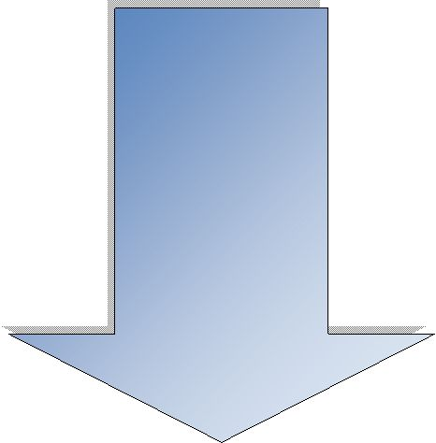
Evaporation happens when water warmed by the sun turns to tiny droplets of water called water vapour.
These rise into the air. Plants and trees also make water vapour.
Condensation happens when water vapour cools high in the air and makes clouds.
This water vapour forms drops and falls back to the earth as rain, hail or snow.
Water which falls to earth makes streams and rivers or soaks into the ground.

