Reading Maps and Using Geospatial Data
Read the Background Pages before attempting the questions | Curriculum Area:  Social Studies Level 3-5 | Strand  Place and Environment  Culture and Organisation  Continuity and Change
Achievement Objectives | Understand how people view and use places differently.
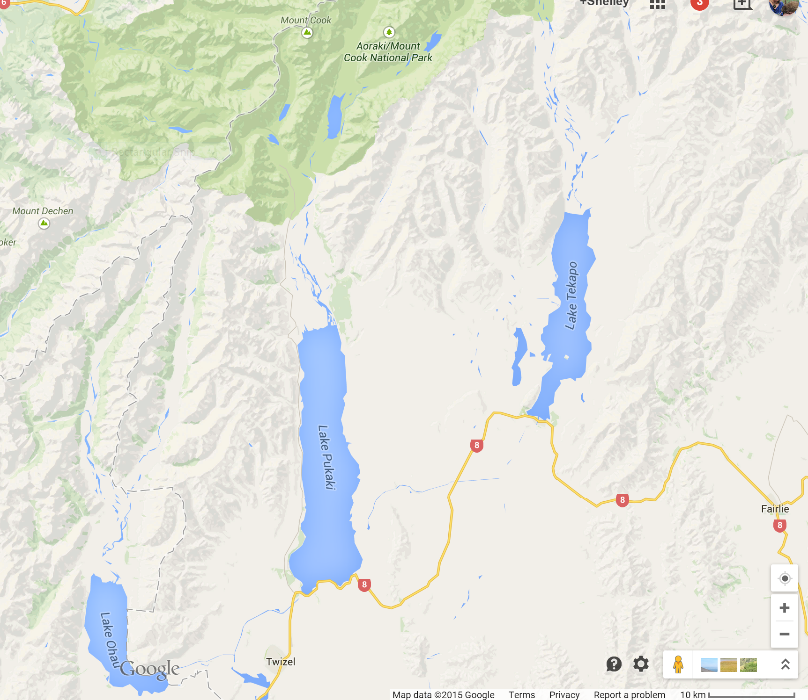
Using google maps, and find the area shown in the map above, then complete the following;
- How many braided rivers can be seen running into high country lakes;__________________
- What are these rivers called_____________________________________________________
- How far are the following from Twizel and in which direction?
- Aoraki Mount Cook __________________________________________________
- Tekapo_________________________________________________________________
- Mount John ______________________________________________________________
- Look at Google Earth or a topographical map of Twizel. What do you notice about the topography (shape of the land) in and around Twizel?__________________________
___________________________________________________________________________
___________________________________________________________________________
- What is the Māori name of the main range of mountains in this area? ___________________________________________________________________________
- How far is Twizel from Timaru?

