Adapting After Emergencies Field Trip Web Quest

Learning Intentions
- Become familiar with LEARNZ website functions.
- Read (skim and scan), watch, listen, and look for information on the Adapting After Emergencies website
- Use the Adapting After Emergencies website to create good (‘fat’) questions
Welcome – Haere Mai
Haere Mai, welcome to the Adapting After Emergencies virtual field trip. During your learning about this topic you will meet real people, doing real jobs, in real places and in real time. So, join me and let’s go exploring on the Adapting After Emergencies website.
Ngā mihi,
Did you know...?
If students have an internet connection at home, they can access these field trips.
Why not have them show someone at home what they are learning about?
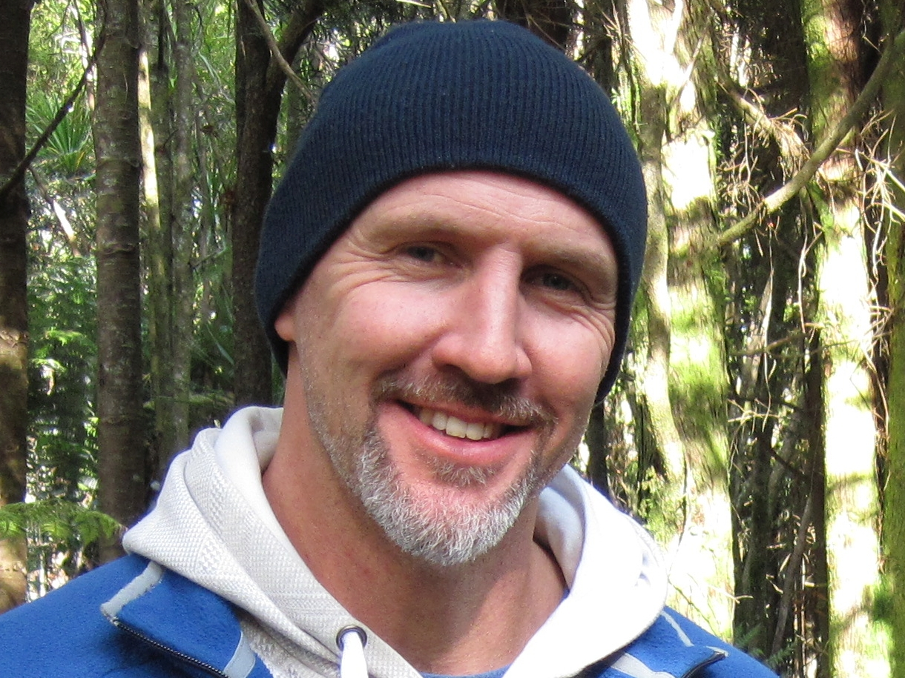
Andrew

Before you Begin...
- Get your LEARNZ class username and password from your teacher
- Go to www.learnz.org.nz
- Click on ‘Field Trips’ or ‘Find a trip’
- Click on Adapting After Emergencies 2018

Turn over to begin your quest...
Web Quest Section 1 – Preparation
(Click on ‘Preparation’ in the left-hand menu bar)
Background Pages: Picture slide-show - When you click on any image in a background page, you will see that it enlarges. In the image you will see arrows that will get you to the next or previous image:
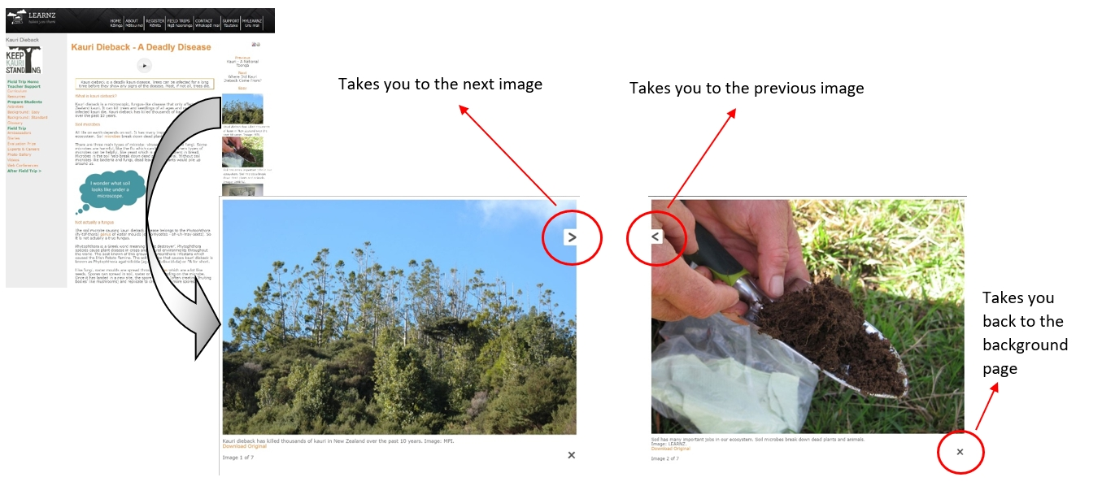

Open a Background page of your choice and click on the first photo. Click Next to view all the other photos. Now use both forward and back arrows to select your favourite photo for that background page. Complete the following:
QUEST TASK
My chosen photo is from the background Page called ____________________________

This photo is about ________________________________________________________

Glossary – The Glossary helps you find definitions of new words from the Background Pages.

Click on ‘Glossary’ and write the meaning of a word that is new to you.
QUEST TASK

My word is: _________________________________

This word means: ______________________________________________________________________

______________________________________________________________________

______________________________________________________________________

Web Quest Section 2 – Field Trip
(Click on ‘Field Trip’ in the left-hand menu bar)
Ambassadors Each class ambassador has their own web page.
QUEST TASK
Go to the Ambassador page and meet the ambassadors. What are their names? ______________________________________________________________________
Imagine that you have your own Class Ambassador on this field trip and are sending him/her a short message. Write a draft for this message:
_______________________________________________________________________
_______________________________________________________________________
_______________________________________________________________________

Web conferences These are where students talk with experts during the field trip. They are great fun, so if you haven’t been a speaking school before, talk to your teacher about getting involved either on this field trip or the next.
QUEST TASK
Have a look at the web conference timetable and the three topics. Select a topic and look at the questions asked by the speaking schools. Select one question that interests you. What is that question?
_______________________________________________________________________
_______________________________________________________________________
Listen to the web conference recording and find the place on the recording where the answer to that question was given. In your own words write the answer to that question:
_______________________________________________________________________
_______________________________________________________________________
_______________________________________________________________________
_______________________________________________________________________

Diaries A detailed diary is written for you to read for each day of the field trip (including the travel day on Tuesday). There are photos taken that day on this page as well.
QUEST TASK
Select one of the diaries for your field trip.
What is the date?  ________________________________ | What is the location of the field trip?  ________________________________
Where’s the field trip teacher today?  ________________________________ | What is the weather like?  ________________________________
Write one fact you learned from reading the diary.
- My fact is:
_______________________________________________________________________
_______________________________________________________________________
_______________________________________________________________________
- Was there a photo relating to this fact? (Circle one) Yes/No

Experts This is where you get to meet and learn about your field trip experts.
QUEST TASK
Read about the experts and complete the following:
- Write the name of the expert you would most like to meet in person:
______________________________________________________________________
- Write an interesting question you would ask that expert:
______________________________________________________________________
______________________________________________________________________

Photo Gallery You can find all the photos from the Adapting After Emergencies field trip here.
QUEST TASK
Keyword Search. Have a go at typing in a key word (one related to the Adapting After Emergencies field trip). Keep trying until you get a result.
- My key word is ___________________
- The number of photos found were _________
- The photo I liked the best was about
________________________________________________________________________________________________________________________________________________
Twitter You can be part of the daily action and really connect to the field trip with your own class Twitter account (see http://www.learnz.org.nz/support/twitter for more information).
Have your teacher set up a class Twitter account. Follow me @andrewpenny01 #learnztrip and receive updates, photos, comments etc. from the field.
QUEST TASK
- Be a contributor! Respond to what is being tweeted from the field with your own thoughts and feelings related to the day’s tweets.
- Share photos or links that highlight your inquiry related to the field trip.
- Chat with other students from around the country also contributing to the field trip via Twitter.

Videos About four videos are made each day of the field trip and help you to get amongst the action.
Select and view one video from each day of the field trip and complete the following:
QUEST TASK

Write the day and video number: | Write one fact you learned from watching this video: | Write your own question about this video topic:

Field Trips Map – You can zoom in on the map to get a better idea of where you are on the field trip.
NB: For field trips from previous years, go to https://www.google.co.nz/maps and enter the field trip location in the search box. Click + to zoom in.

Access the LEARNZ Field Trips page map (http://www2.learnz.org.nz/core-fieldtrips.php). Zoom in on the LEARNZ flag showing where the Adapting After Emergencies field trip is taking place and complete the following:
QUEST TASK

- Which state highway number is nearest to the field trip location (see the number in the shield)? SH_____
- What is the nearest town to the field trip location? ____________________________
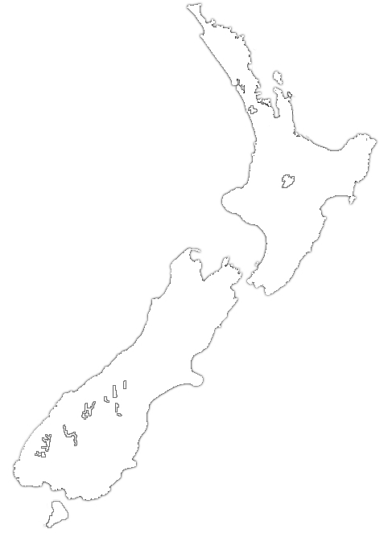
- Put a cross on this map to show where your field trip is located.
- Draw a small house on this map to show where you live.
- Draw a line from your house to the field trip location.

✶                       

Self-Assessment
Learning Intention | ☹ | 😐 | ☺
I know more about the Adapting After Emergencies website functions
I can read, watch, listen, and look for information on the Adapting After Emergencies website
I can use the Adapting After Emergencies website to create good (‘fat’) questions

