LEARNZ Field Trip Web Quest

Learning Intentions
- Become familiar with LEARNZ website functions.
- Read (skim and scan), watch, listen, and look for information on a LEARNZ field trip website of your choice
- Use your chosen field trip website to create good (‘fat’) questions
Welcome
Welcome to your LEARNZ virtual field trip. During your learning about this topic you will meet real people, doing real jobs, in real places and in real time. So, get ready and come exploring with me on a LEARNZ field trip website.
Best
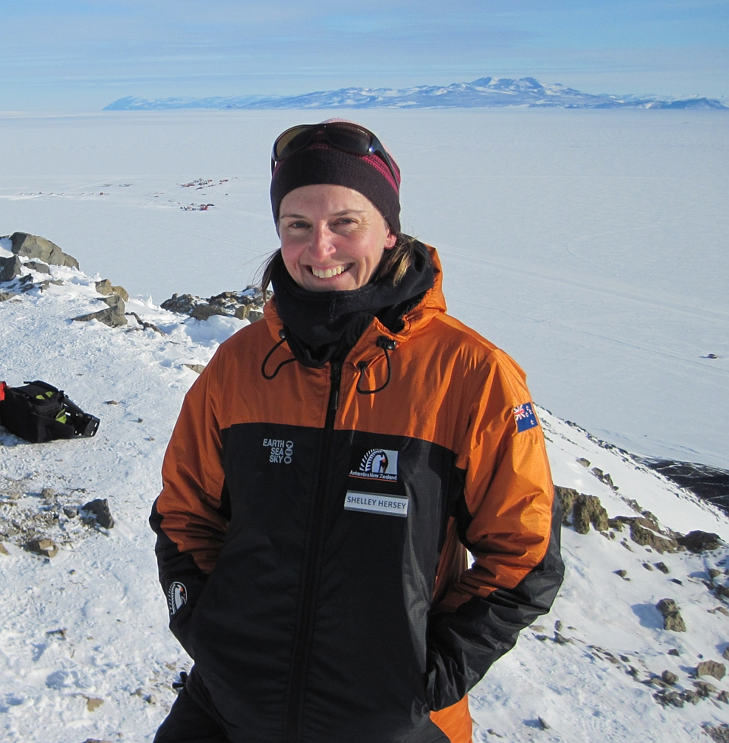
Did you know...?
If students have an internet connection at home they can access these field trips.
Why not have them show someone at home what they are learning about?
Shelley
Before you Begin...
- Get your LEARNZ class username and password from your teacher (not all field trips require a login)
- Go to www.learnz.org.nz
- Click on ‘Field Trips’ or ‘Find a trip’
- Click on a field trip of your choice

Turn over to begin your quest...
Web Quest Section 1 – Preparation
(Click on ‘Preparation’ in the left hand menu bar)
Background Pages: Picture slide-show - When you click on the first picture in a Background page, you will see that it enlarges. Below the pictures there are three word links Previous, More and Next:
Takes you back to the page
Takes you to the next photo
Takes you to the photo before
Previous | More | Next
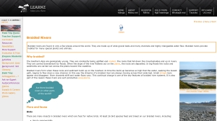

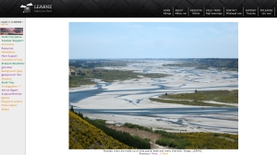

Open a Background page of your choice and click on the first photo. Click Next to view all the other photos. Now use both Previous and Next to select your favourite photo for that Background page. Complete the following:
QUEST TASK
My chosen photo is from the Background Page called ____________________________

This photo is about ________________________________________________________

Glossary – Like text roll-overs, the Glossary helps you find definitions of new words from the Background Pages.

Click on ‘Glossary’ and write the meaning of a word that is new to you.
QUEST TASK

- Word ___________________ Definition _________________________________________________

Background Pages: Text roll-overs – These are words in Background Pages that are in a different colour (usually orange) to the rest of the text. When you use the mouse to ‘hover’ over these orange words you will see the meaning of that word appear in a small box.

QUEST TASK
Find one text roll-over word that interests you from a Background Page. Write the word and its definition here.

- Word ___________________ Definition _________________________________________________

Web Quest Section 2 – Field Trip
(Click on ‘Field Trip’ in the left hand menu bar)
Ambassadors Each class ambassador has their own web page.
QUEST TASK
Go to the Ambassador page and meet the ambassadors. What are their names? ______________________________________________________________________
Imagine that you have your own Class Ambassador on this field trip and are sending him/her a short message. Write a draft for this message:
_______________________________________________________________________
_______________________________________________________________________
_______________________________________________________________________
Informal web conference question session – After each formal web conference there is an opportunity for schools listening through the LEARNZ meeting room to ask extra questions. Questions can be typed and a selection will be answered during this session. This is the place where you can ask questions that have not been answered from your involvement in your chosen field trip web site. Questions could come from background pages, activities, web conferences, class discussion etc. Remember that this session follows the daily formal web conference live during the field trip.
Enter the LEARNZ meeting room during the timetabled live web conference. Follow the link from the newsletter.
QUEST TASK
- My Question is ______________________________________________________________________
_____________________________________________________________________________________
Summarise the answer here:
____________________________________________________________________________________
____________________________________________________________________________________
____________________________________________________________________________________
____________________________________________________________________________________

Web conferences These are where students talk with experts during the field trip. They are great fun, so if you haven’t been a speaking school before, talk to your teacher about getting involved either on this field trip or the next.
QUEST TASK
Have a look at the web conference timetable and the three topics. Select a topic and look at the questions asked by the speaking schools. Select one question that interests you. What is that question?
_______________________________________________________________________
_______________________________________________________________________
Listen to the web conference recording and find the place on the recording where the answer to that question was given. In your own words write the answer to that question:
_______________________________________________________________________
_______________________________________________________________________
_______________________________________________________________________
_______________________________________________________________________

Diaries A detailed diary is written for you to read for each day of the field trip (including the travel day). There are photos taken that day on this page as well.

Select one of the diaries for your field trip.
QUEST TASK
What is the date?  ________________________________ | What is the location of the field trip?  ________________________________
Where’s the field trip teacher today?  ________________________________ | What is the weather like?  ________________________________

Write one fact you learned from reading the diary.
- My fact is:
_______________________________________________________________________
_______________________________________________________________________
_______________________________________________________________________
- Was there a photo relating to this fact? (Circle one) Yes/No

Experts This is where you get to meet and learn about your field trip experts.
QUEST TASK
Read about the experts and complete the following:
- Write the name of the expert you would most like to meet in person:
______________________________________________________________________
- Write an interesting question you would ask that expert:
______________________________________________________________________
______________________________________________________________________
Photo Gallery You can find all the photos from your field trip here.
QUEST TASK
Keyword Search. Have a go at typing in a key word (one related to the field trip you have chosen). Keep trying until you get a result.
- My key word is ___________________
- The number of photos found were _________
- The photo I liked the best was about
________________________________________________________________________________________________________________________________________________
Twitter You can be part of the daily action and really connect to the field trip with your own class Twitter account (see http://www.learnz.org.nz/support/twitter for more information).
Have your teacher set up a class Twitter account. Follow me @ShelleyHersey #learnztrip and receive updates, photos, comments etc. from the field.
QUEST TASK
- Be a contributor! Respond to what is being tweeted from the field with your own thoughts and feelings related to the day’s tweets.
- Share photos or links that highlight your inquiry related to the field trip.
- Chat with other students from around the country also contributing to the field trip via Twitter.
Videos About four videos are made each day of the field trip and help you to get amongst the action.
Select and view one video from each day of the field trip and complete the following:
QUEST TASK
Write the day and video number: | Write one fact you learned from watching this video: | Write your own question about this video topic:

Field Trips Map – You can zoom in on the map to get a better idea of where you are on the field trip.
NB: For field trips from previous years, go to https://www.google.co.nz/maps and enter the field trip location in the search box. Click + to zoom in.

Access the LEARNZ Field Trips page map (http://www2.learnz.org.nz/core-fieldtrips.php). Zoom in on the LEARNZ flag showing where your field trip is taking place and complete the following:
QUEST TASK
- Which state highway number is nearest to the field trip location (see the number in the shield)? SH_____
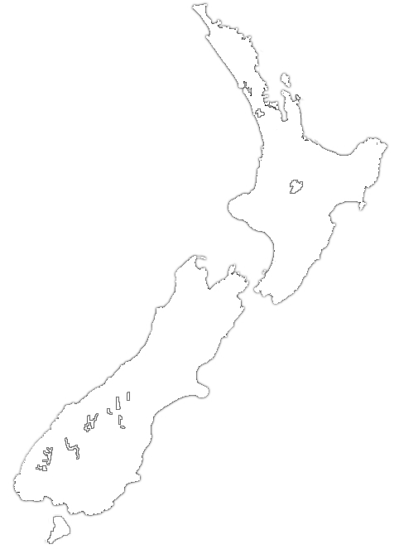
- What is the nearest town to the field trip location? ____________________________
- Put a cross on this map to show where your field trip is located.
- Draw a small house on this map to show where you live.
- Draw a line from your house to the field trip location.

Self Assessment
Learning Intention | ☹ | 😐 | ☺
I know more about the field trip website functions
I can read, watch, listen, and look for information on the field trip website
I can use the field trip website to create good (‘fat’) questions

