Earthlearningidea

Waves in the Earth – Earthlearningidea 1 - The slinky simulation

Using a long spring to find out how earthquake waves travel through the Earth
Model how seismic waves travel through the Earth as follows:
- Explain that when an earthquake occurs, rocks fail suddenly and the energy released can travel both round the Earth and through it. We can model the ways in which the energy travels through the Earth using a “slinky” spring.
- Stretch out the slinky on the bench top (or in the air) and ask a pupil to hold the other end.
- Take a few coils of the slinky in your hand and suddenly let them go. This produces a ‘pushpull’ motion in the coils of the spring and a wave can be seen travelling along it until the pupil at the far end can feel it arriving. (The wave will also reflect back and forth a few times). This is a longitudinal wave, known to seismologists as a P wave, because it arrives before any other type of wave and is therefore the Primary wave. It can also be visualised as a push/pull, or compressional wave.
- Now give the spring a sharp sideways shake. This produces a transverse wave, which will
reach the far end and reflect back and forth as before. Such waves are always slower than the P waves and are known as S waves or Secondary waves, since they arrive second (also slow, sideways, shake or shear waves).
- Explain that one earthquake causes both P and S waves. However, the waves which cause most damage to life and property are surface waves, which are transmitted around the world at the Earth’s surface much like a water wave on the sea surface. (It is not possible to model the movement of surface waves round the Earth using a slinky).

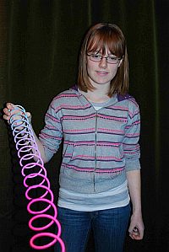
Modelling P and S waves with a cheap toyshop slinky
………………………………………………………………………………………………………………..……
The Back Up
Title: Waves in the Earth 1 - the slinky simulation
Subtitle: Using a long spring to find out how earthquake waves travel through the Earth
Topic: A demonstration using a slinky spring. This is well known as an aid in teaching the physics of wave motion but is applied here to the transmission of earthquake waves through the Earth.
Age range of pupils: 14-18 years
Time needed to complete activity: 10 minutes
Pupil learning outcomes: Pupils can:
- explain how energy is transmitted through a spring;
- appreciate that the parts of the spring move backwards and forwards, or sideways, but do not change their final positions;
- use their observations to understand how energy may be transmitted though the Earth.
Context:
The activity may be used to enhance the teaching of physics as it is applied to understanding theinterior of the Earth.

Follow up activity:
If several slinky springs are available, they can be used side by side to demonstrate the higher velocity of travel of P waves compared to S waves, as in the photograph below.

Earthlearningidea 2

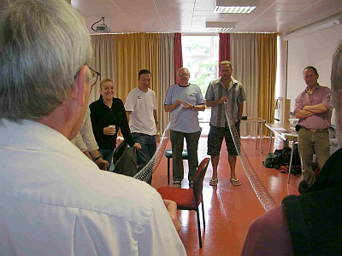
Two slinky springs being used to compare the speed of P and S waves (Photos: Peter Kennett).

Carry out the Earthlearningidea activity, ‘Waves in the Earth 2 - Human molecules’. This will enable pupils to appreciate why P waves can be transmitted through both solids and liquids, whilst S waves can only be transmitted through solids. A slinky can also be fastened to the middle of another one, at right angles to it, and then used to demonstrate that an S wave can be generated by the arrival of a P wave. This explains how S waves can be generated in the solid inner core of the Earth by a P wave that had travelled through the liquid outer core.

Underlying principles:
- Wave motion involves the molecule-by-molecule movement of the medium through which the wave is being transmitted.
- P waves travel faster than S waves.
- P wave velocity is directly proportional to the rigidity of the medium and its resistance to compression. It is inversely proportional to its density.
- S wave velocity is directly proportional to the rigidity of the medium, and inversely proportional to its density.

Thinking skill development:
Relating the slinky activity to the passage of real earthquake waves through the Earth involves bridging.

Resource list:
- one or more slinky springs. Long steel slinky springs are obtainable from laboratory suppliers. Toy shops sell brightly coloured plastic springs more cheaply that illustrate the principles just as well. The motion of the spring is made more obvious if coloured spots are glued or painted on to several coils in the middle of the spring

© Earthlearningidea team. The Earthlearningidea team seeks to produce a teaching idea regularly, at minimal cost, with minimal resources, for teacher educators and teachers of Earth science through school-level geography or science, with an online discussion around every idea in order to develop a global support network. ‘Earthlearningidea’ has little funding and is produced largely by voluntary effort.
Copyright is waived for original material contained in this activity if it is required for use within the laboratory or classroom. Copyright material contained herein from other publishers rests with them. Any organisation wishing to use this material should contact the Earthlearningidea team.
Every effort has been made to locate and contact copyright holders of materials included in this activity in order to obtain their
permission. Please contact us if, however, you believe your copyright is being infringed: we welcome any information that will help us to update our records. If you have any difficulty with the readability of these documents, please contact the Earthlearningidea team for further help.
Contact the Earthlearningidea team at: info@earthlearningidea.com

