Surveying |  | Curriculum Area:  Mathematics and Statistics, Level 5-6 | Strand:  Geometry and Measurement
Achievement Objectives: | Apply trigonometric ratios and Pythagoras’ theorem in two dimensions
Learning Intention: | Apply laws of trigonometry to find the location of a set point

A surveyor marks 2 positions on one side of the Avon River, a metre off the bank, measures 78.10 metres between them, then sets up a theodolite at each position and measures the angles at A & B to 0.
Question; What is the width of the of the Avon River at Point 0?
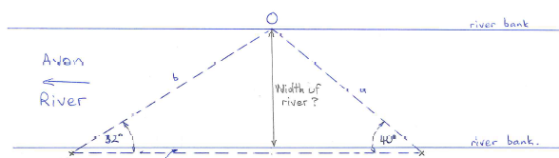
Baseline = 78.10 metres
Avon River
River bank
River bank
b
B
a
Width of River?
O
A
Baseline is 1 metre off the river bank
Angle A = 32 degrees
Angle B = 40 degrees
[Use the sine rule to find the unknown sides of the triangle]
Show your working here:

