The Language of Location Answers
Read the Background Pages before attempting the questions | Curriculum Area:  Social Studies Level 3-5 | Strand  Place and Environment
Achievement Objectives | Understand how people view and use places differently.
1. What does geospatial data mean; Information about location, or where things are.
2. Explain what latitude means; imaginary lines across the globe parallel to the equator
3. Explain what longitude means; imaginary vertical lines which converge at the poles
4. Draw in lines of latitude and longitude on the picture below. Label the equator and poles.
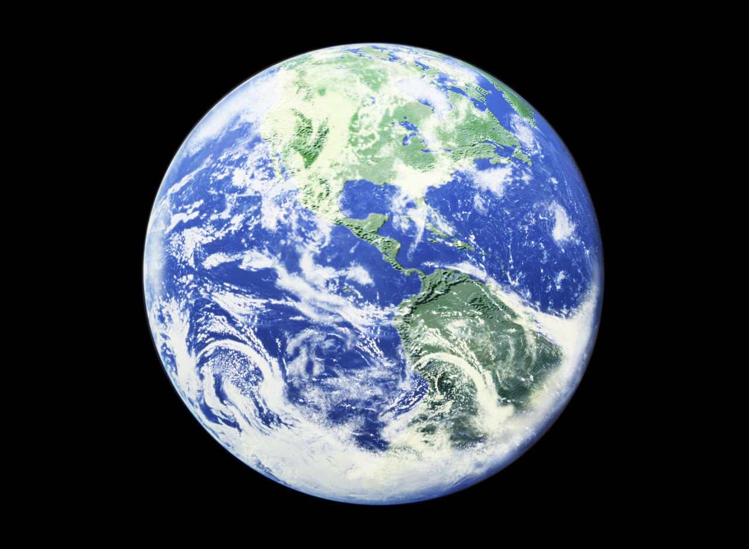
5. Describe all the times when a map has been useful to you over the last month; Answers will vary but may include, finding a new shop or friend’s house, getting to the correct bus stop, planning a walk/hike/run, travelling to another part of the city….
Use google maps - http://maps.google.co.nz and locate your home, school and nearest library.
Find the distance between your home and school ___________________________km and between your home and nearest library ________________________________km.
Draw a simple map in the box
provided (or on the back) to show how you got from home to school today. What challenges did you face when drawing this map; Not having enough space, working out a scale and keeping to it, not knowing exact distances, orientating the map…..

