The Language of Location
Read the Background Pages before attempting the questions | Curriculum Area:  Social Studies Level 3-5 | Strand  Place and Environment
Achievement Objectives | Understand how people view and use places differently.
1. What does geospatial data mean; ____________________________________________________
__________________________________________________________________________________
2. Explain what latitude means;________________________________________________________
__________________________________________________________________________________
3. Explain what longitude means;_______________________________________________________
__________________________________________________________________________________
4. Draw in lines of latitude and longitude on the picture below. Label the equator and poles.
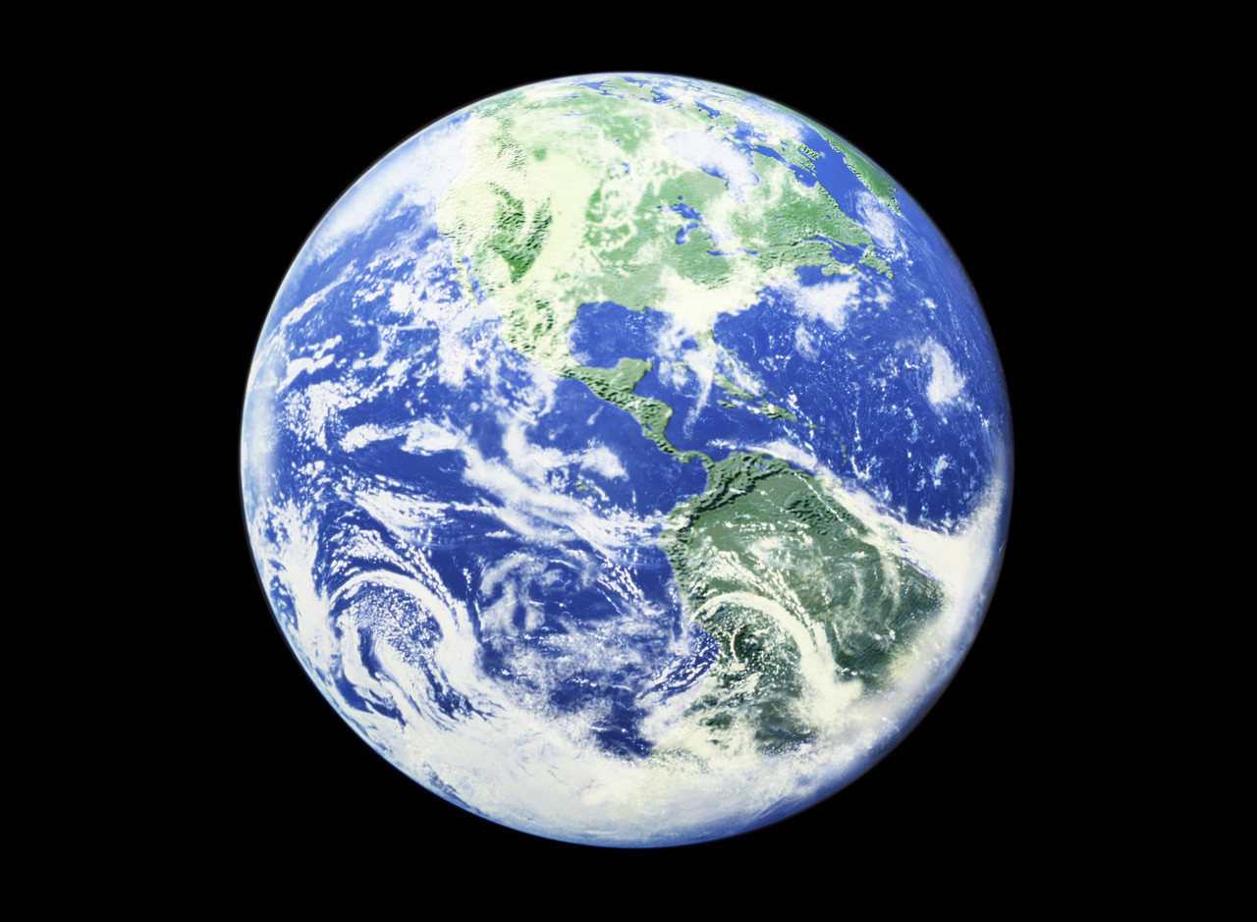
5. Describe all the times when a map has been useful to you over the last month;________________
__________________________________________________________________________________
__________________________________________________________________________________
Use google maps - http://maps.google.co.nz and locate your home, school and nearest library.
Find the distance between your home and school ___________________________km and between your home and nearest library ________________________________km.
Draw a simple map in the box
provided (or on the back) to show how you got from home to school today. What challenges did you face when drawing this map

