TOPOGRAPHIC MAPS
Questions (to go with Map 1 below)
1. If the first contour on this map is at mean sea level, what elevation is each of the following points? (contour interval = 20 metres.)
A | ___________ | B | ___________ | C | ___________
1 | ___________ | 2 | ___________ | 3 | ___________
2. Which is the steepest slope on the hill? (north, south, east, or west?)
How do you know?
3. What is the difference in elevation between the second and fourth layers of this map?
4. If you were to build a house on this hill, where is the flattest part of the land form?
Draw a house on the topographic map at the flattest point.
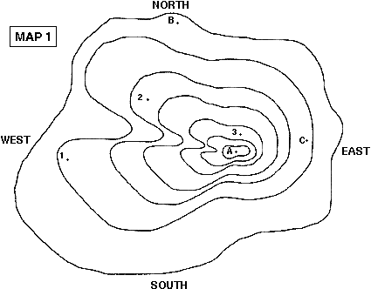
Make Your Own Topographic Map:
- Using modelling clay, plasticine or a similar material; make a model of a hill. Include features such as valleys, gentle sloping areas as well as steeper terrain. You could make your model to look similar to a hill in your local area. Make sure your model is at least 10 centimetres in height.
- Using a ruler and a pencil mark off points on your model at 2 centimetre height intervals – these will model 20 metre contour lines.
- Take a 30-40 centimetre length of fishing line or nylon thread. Use this to cut through your model at every 2 centimetre height interval or contour. Make sure you keep the thread tight and level while cutting.
- Put aside each layer carefully so you do not alter its shape.
- On a piece of paper draw around each layer starting with the base layer until you have drawn all your contour lines.
- Mark the summit in by estimating where the highest point is on your map and using your contour lines estimate the height. Write this highest point on your map.
You have now made your very own topographical map!
- Compare your map with the one below and describe the similarities and differences.
______________________________________________________________________________________________________________________________________________________
___________________________________________________________________________
___________________________________________________________________________
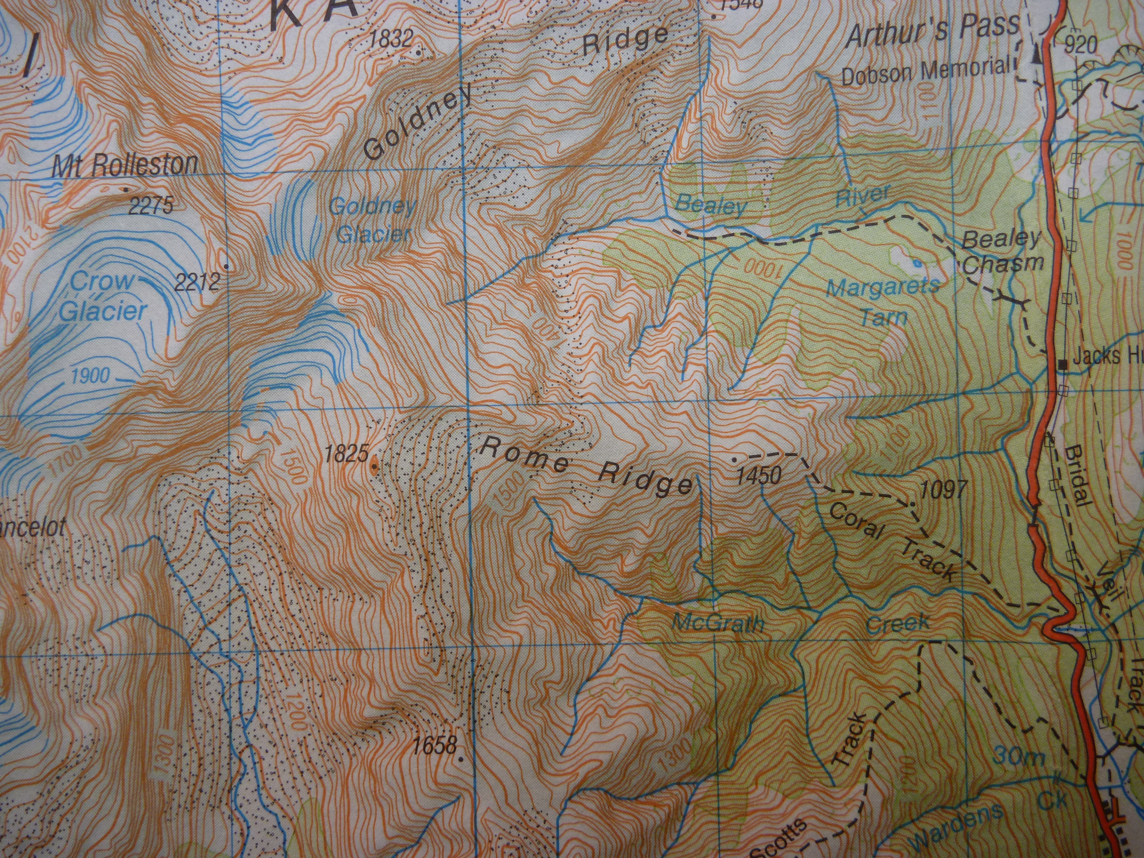
Reading Maps
- What is the highest point on this map?____________________________________________
- What height is Arthur’s Pass?_________________________________
- What do you notice about the three main tracks that are marked on the map?____________
___________________________________________________________________________
___________________________________________________________________________
- Where is the steepest slope on the map and how do you know?_______________________
___________________________________________________________________________
___________________________________________________________________________
- Why are some of the contour lines blue?__________________________________________
___________________________________________________________________________

