Web of Life - Answers
Curriculum Area:  Science Level 3 & 4 |  | Strands:  Living World | Nature of Science | Background Pages:  Lake Taupo’s Web of Life
Achievement Objectives | Life Processes Levels 3-4: Recognise that there are life processes common to all living things and that these occur in different ways.  Communicating in Science Levels 3-4: Begin to use a range of scientific symbols, conventions, and vocabulary

- All animals live in communities with other plants and animals. We can show relationships as the flow of energy such as this food chain:

leaf litter insects bellbird

a) Lakes and rivers have food chains. Use arrows to show the transfer of energy through the food chain below.

microscopic plants smelt trout

b) What words do you think the arrows represent? Eaten by

c) A food web shows the flow of energy in a habitat as a whole. Complete three food chains found in the food web illustrated below.

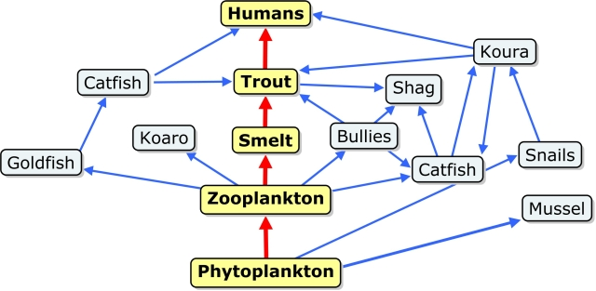
1.
Answers will vary
2.

3.

d) Now write the longest food chain you can see in the marine food web above.

Answers will vary – Any chain with six links

