Webs and Chains

Curriculum Area:  Science Level 1 & 2 |  | Strand:  Nature of Science | Background Page:  Lake Taupo’s Web of Life
Achievement Objectives | Communicating in Science 1-2: Build their language and develop their understandings of the many ways the natural world can be represented.
Using this food web, make your own food chain with four links.

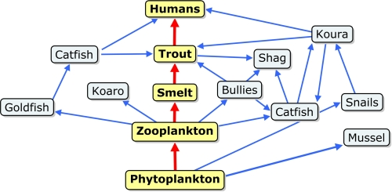

MY FOOD CHAIN – Example Answer

zooplankton

Answers will vary
catfish

koura

humans

