A Whio in My Neighbourhood? - ANSWERS
Curriculum Area:  Science Level 3 & 4 |  | Strand:  Living World | Background Pages:  Whio – A Freshwater Indicator Species | Lake Taupō’s Web of Life
Achievement Objectives | Ecology Levels 3-4: Explain how living things are suited to their particular habitat and how they respond to environmental changes, both natural and human-induced.

- Describe where whio like to live.

In and around cold, fast flowing, clean rivers.
- List the things that whio like to feed on.
larvae of caddisfly
larvae of mayfly
larvae of stonefly
freshwater snails

- Why don't you usually see whio in urban or suburban neighbourhoods? Give at least three reasons. Give at least three reasons.

(a) There are dogs and cats nearby which prey on whio.

(b) The river or stream is not clean enough/fast flowing enough.

(c) They are only found in some parts of the North and South Island.

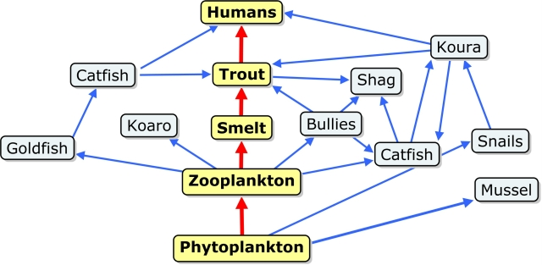
- Add whio and one other living thing related to whio to this food web.
Aquatic insects
whio

