A Whio in My Neighbourhood?
Curriculum Area:  Science Level 3 & 4 |  | Strand:  Living World | Background Pages:  Whio – A Freshwater Indicator Species | Lake Taupō’s Web of Life
Achievement Objectives | Ecology Levels 3-4: Explain how living things are suited to their particular habitat and how they respond to environmental changes, both natural and human-induced.

- Describe where whio like to live.
______________________________________________________________________________

______________________________________________________________________________

______________________________________________________________________________

- List the things that whio like to feed on.
________________________________
________________________________
________________________________
________________________________

- Why don't you usually see whio in urban or suburban neighbourhoods? Give at least three reasons.

(a) _________________________________________________________________________

(b) _________________________________________________________________________

(c) _________________________________________________________________________

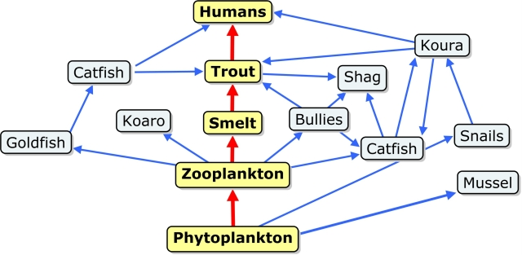
- Add whio and one other living thing related to whio to this food web.

